Online Cloud-Enabled Bookstore System

##### A Project Report

**Submitted by:**

##### Kaustubh Naithani, Prashant Kumar, Dhruva Malik, Mohammed Bilal

**University Roll Number 20BCS4000, 20BCS4363**

**20BCS3976**

#### in partial fulfillment for the award of the degree of BACHELOR OF ENGINEERING

##### IN

**COMPUTER SCIENCE (Big Data and Analytics)**

##### Under the Supervision of: Ms. Pooja Jaiswal



**CHANDIGARH UNIVERSITY, GHARUAN, MOHALI - 140413,**

##### PUNJAB

**MONTH & YEAR May 2023**

|  |  |  |
| --- | --- | --- |
| **Table of Contents** |  |  |
| Title Page | 1 |
| Table of contents | 2 |
| List of tables | 3 |
| List of figures | 4-5 |
| Candidate Declaration | 6 |
| Abstract | 7 |
| Acknowledgement | 8 |
| **1. Introduction** | **9-18** | **1** |
| 1.1 Problem Statement | 9-10 |  |
| 1.2 Problem Formulation | 10-11 |  |
| 1.3 Background and motivation | 11-12 | 1 |
| 1.4 Objectives | 12-13 |  |
| 1.5 Report Organization | 13 |  |
| 1.6 Software tool Specifications | 13-16 |  |
| 1.7 Hardware and Software Requirements | 16-17 |  |
| 1.8 Feasibility of the Project | 17 |  |
| 1.9 Scope of Project | 18 | 5 |
| **2. Literature Review** | **19-30** |  |
| **3. System Design** |  |  |
| 3.1 DFD Diagram | 31 |  |
| 3.2 Use case diagram | 32-33 |  |
| 3.3 User Interface Design | 33-50 |  |
| **4. Methodology** |  |  |
| 4.1 Methodology Used | 51-52 |  |
| 4.2 Tools | 52 |  |
| 4.3 Requirements | 53 |  |
| 4.4 Implementation and Testing | 53-55 |  |
| **5. Conclusion** | **56-57** |  |
| **Future Scope** | **58-59** |  |
| **References** | **60** |  |

# List of Tables

|  |  |  |
| --- | --- | --- |
| **Table name** | **Table Description** | **Page No.** |
| **Table 1** | Existing Features and the features that can be  implemented | 30 |
| **Table 2** | Login | 53 |
| **Table 3** | Adding New Books | 54 |
| **Table 4** | Adding New category | 54 |
| **Table 5** | Ordering Book | 55 |

**List of Figures**

|  |  |  |
| --- | --- | --- |
| **Figure name** | **Figure Description** | **Page No.** |
| Figure 2.1 | System Architecture Diagram | 22 |
| Figure 2.2 | UML Design | 23 |
| Figure 2.3 | Comparing Different Cloud Platforms | 26 |
| Figure 2.4 | Cloud Market Share | 28 |
| Figure 3.1 | DFD Diagram | 31 |
| Figure 3.2 | Use Case Diagram | 32 |
| Figure 3.3 | Home Page | 33 |
| Figure 3.4 | Welcome Page 1 | 34 |
| Figure 3.5 | Welcome Page 2 | 34 |
| Figure 3.6 | Welcome Page 3 | 35 |
| Figure 3.7 | Shopping Cart | 35 |
| Figure 3.8 | Payment Options | 36 |
| Figure 3.9 | Payment Screen | 36 |
| Figure 3.10 | Order Confirmation Screen | 37 |
| Figure 3.11 | Customer Login | 37 |
| Figure 3.12 | Customer Sign in | 38 |
| Figure 3.13 | Manager Login | 38 |
| Figure 3.14 | Manager sign up | 39 |
| Figure 3.15 | My Bookstore | 39 |
| Figure 3.16 | View Book Items | 40 |
| Figure 3.17 | Add Book Items | 40 |
| Figure 3.18 | Edit Book Items | 41 |
| Figure 3.19 | Delete Book Items | 41 |
| Figure 3.20 | Order History | 42 |
| Figure 3.21 | Images Folder | 42 |
| Figure 3.22 | Server on amazon AWS | 43 |
| Figure 3.23 | EC2 Instance Details | 43 |
| Figure 3.24 | The Storage Details | 44 |
| Figure 3.25 | Security Details | 44 |

|  |  |  |
| --- | --- | --- |
| Figure 3.26 | Connecting To Instance Using RDP | 45 |
| Figure 3.27 | Password for Windows Server | 45 |
| Figure 3.28 | Networking  Information of the instance | 46 |
| Figure 3.29 | Server Statistics of The Instance | 46 |
| Figure 3.30 | Database of Customer Details | 47 |
| Figure 3.31 | Table of Customer Login Credentials | 47 |
| Figure 3.32 | List of all books in database | 48 |
| Figure 3.33 | Table of Manager Login Credentials | 48 |
| Figure 3.34 | Database of Books ordered | 49 |
| Figure 3.35 | Table of individual user bookstore | 49 |

## CANDIDATE'S DECLARATION

We, ‘Kaustubh Naithani’, ‘Dhruva Malik’, ‘Prashant Kumar’, student of ‘Bachelor of Engineering in CSE Big Data Analytics’, session: 2023, Department of Computer Science and Engineering, Apex Institute of Technology, Chandigarh University, Punjab, hereby declare that the work presented in this Project Work entitled ‘Online Cloud Enabled Bookstore System’ website is the outcome of our own bona fide work and is correct to the best of our knowledge and this work has been undertaken taking care of Engineering Ethics. It contains no material previously published or written by another person nor material which has been accepted for the award of any other degree or diploma of the university or other institute of higher learning, except where due acknowledgment has been made in the text.

# ABSTRACT

The project "Virtual Mouse Using Hand Gestures" explores the innovative application of computer vision and machine learning technologies to create an intuitive and efficient human-computer interaction system. In an era where the traditional computer mouse and keyboard interfaces are evolving, this project focuses on offering a novel and more natural means of interacting with computers.

This research project leverages computer vision algorithms and a camera-based input system to detect and interpret hand gestures, translating them into corresponding mouse movements and actions on a computer screen. Through the integration of machine learning models, our system is capable of recognizing a variety of hand gestures, such as pointing, clicking, scrolling, and dragging, enabling a seamless and touchless interaction experience.

The results of this project demonstrate the potential for more immersive and hands-free computer control, making it particularly relevant in scenarios where traditional input devices are impractical or cumbersome, such as in virtual reality, presentations, and accessibility applications. Challenges encountered during development, including gesture recognition accuracy and real-time responsiveness, are discussed and solutions proposed.

"Virtual Mouse Using Hand Gestures" project represents an exciting advancement in the realm of human-computer interaction, showcasing the capabilities of modern computer vision and machine learning technologies. The system's successful implementation suggests a promising future for touchless computer control, bringing us one step closer to a more intuitive

and convenient computing experience.

# ACKNOWLEDGEMENT

We would like to express our deep and sincere gratitude to our Project respected in charge Dr. Monica Singh for giving us the opportunity to do the project and providing valuable guidance throughout this research. Their dynamism, vision and exquisite efforts have deeply inspired us. They taught us the methodology to carry out the research and to present the research work as clearly as possible. It was a great privilege for us to study and work under their guidance. We owe the completion of my project to our project Mentor for her continuous support and guidance.

# Chapter 1 Introduction

A cloud-enabled bookstore system is a software solution that enables a bookstore to operate more efficiently by leveraging cloud computing technology. Cloud computing allows the system to store and process data on remote servers, providing scalability, flexibility, and accessibility to the system.

The system can include various components, such as an online store, inventory management, order processing, customer management, analytics, and reporting. The online store component can allow customers to browse and purchase books online, while the inventory management component can help store owners keep track of their stock levels and make informed purchasing decisions.

Examples of cloud-enabled bookstore systems include:

* Amazon Kindle Direct Publishing (KDP): KDP is a self-publishing platform that allows authors and publishers to upload and sell their books on Amazon's online store. The platform uses cloud computing to provide authors and publishers with access to a global audience, automated royalties, and easy-to-use tools for formatting and publishing their books.
* Barnes & Noble Nook: Nook is a digital reading platform that offers access to millions of books, magazines, and newspapers. The platform uses cloud computing to synchronize users' reading progress across multiple devices, allowing them to pick up where they left off on any device.
* Google Books: Google Books is a digital library that offers access to millions of books and magazines. The platform uses cloud computing to store and process the vast amount of data required to provide users with search, preview, and purchase options.
* Book Logix: Book Logix is a cloud-based publishing platform that provides authors and publishers with a range of services, including editing, formatting, printing, and distribution. The platform uses cloud computing to streamline the publishing process and provide authors and publishers with access to a global audience.
* Overall, cloud-enabled bookstore systems are becoming increasingly popular in the digital age, as they provide bookstores, authors, and publishers with a range of benefits, such as cost savings, scalability, accessibility, and flexibility.

### Problem Statement

The problem statement of an Online Cloud-Enabled Bookstore System would be to create a digital platform that allows users to browse, search, purchase, and receive books online. The system would need to be cloud-enabled, meaning that it is accessible from anywhere with an internet connection and that the data and resources are hosted on the cloud.

The system should have features such as a user-friendly interface for browsing and searching books, secure payment processing for online transactions, and efficient inventory management to ensure that books are in stock and orders are fulfilled in a timely manner. The system should also include customer support features such as the ability to track orders and communicate with customer service representatives.

To create an effective Online Cloud-Enabled Bookstore System, the developers would need to consider issues such as website performance, security, scalability, and user experience. Additionally, the system would need to integrate with various third-party systems such as payment gateways, shipping providers, and inventory management software to ensure seamless operation.

The goal of an Online Cloud-Enabled Bookstore System is to provide a convenient and efficient way for users to purchase books online while also optimizing the bookstore's operations and improving customer satisfaction.

### Problem Formulation

* Develop a user-friendly platform that allows customers to browse, purchase, and receive books online: The platform should be easy to navigate and provide a seamless experience to customers. Customers should be able to browse through the collection of books, view detailed information about each book, and add them to their cart.
* Provide a convenient and secure way for customers to access a vast collection of books and purchase them using various payment methods: The platform should provide customers with various payment options such as credit card, debit card, net banking, and digital wallets. The payment gateway should be secure and compliant with the relevant security standards to protect customers' financial information.
* Ensure easy management of inventory, orders, and shipments for the bookstore owners: The system should provide bookstore owners with an easy-to-use

dashboard to manage their inventory, orders, and shipments. They should be able to view the status of their orders, manage their inventory, and track shipments from a single platform.

* Ensure scalability of the system to handle a large number of users and transactions: The system should be designed to handle a large number of users and transactions without any performance issues. The platform should be able to scale up or down based on the traffic and usage.
* Ensure reliability of the system to minimize downtime and ensure uninterrupted service to customers: The system should be reliable and available at all times to ensure uninterrupted service to customers. The platform should be monitored 24/7 to detect and resolve any issues that may arise.
* Implement robust security measures to ensure the safety of customer data and transactions: The platform should implement robust security measures to ensure the safety of customer data and transactions. The platform should be compliant with industry standards such as PCI DSS, GDPR, and CCPA.
* Enhance the user experience by providing personalized recommendations, easy navigation, and seamless checkout: The platform should provide customers with personalized book recommendations based on their browsing history and purchase patterns. The platform should be easy to navigate, and the checkout process should be seamless.
* Increase sales by providing targeted promotions and discounts to customers: The platform should provide targeted promotions and discounts to customers based on their purchase history and browsing patterns. This will help increase customer engagement and drive more sales

### Background and motivation

The background motivation behind developing an Online Cloud-Enabled Bookstore System stems from the growing popularity of online shopping and the convenience it offers to customers. With the advent of digital technology, people have become increasingly reliant on the internet to purchase goods and services, including books. Moreover, the COVID-19 pandemic has accelerated the shift towards online shopping as more people are avoiding physical stores to minimize the risk of infection.

In this context, a cloud-enabled bookstore system provides a way for bookstores to reach a wider audience and meet the evolving needs of customers. By hosting the system on the cloud, users can access the platform from anywhere with an internet connection, making it more convenient for them to browse and purchase books. The

system's scalability allows bookstores to handle a large number of users simultaneously, ensuring that they don't miss out on potential sales during peak periods.

An Online Cloud-Enabled Bookstore System also provides several benefits to the bookstore itself. By automating the ordering and fulfillment process, bookstores can streamline their operations and reduce the overhead costs associated with physical stores. The system's inventory management features can help bookstores optimize their stock levels, reducing the risk of overstocking or understocking. Additionally, the system's data analytics capabilities can provide valuable insights into customer behavior and preferences, allowing bookstores to make data-driven decisions and improve their marketing strategies.

An Online Cloud-Enabled Bookstore System is motivated by the need to provide a convenient and efficient way for users to purchase books online while also optimizing the operations of bookstores and improving customer satisfaction.

### Objectives

The proposed work is aimed to carry out work leading to the development of an approach for cloud enabled bookstore system. The proposed aim will be achieved by dividing the work into followingobjectives:

* To provide a user-friendly platform for customers to browse and purchase books online, with features such as personalized recommendations, real-time inventory management, and easy payment options.
* To improve the efficiency of the bookstore's operations by automating inventory management, reducing manual data entry, and enabling seamless communication between different departments.
* To increase the visibility and reach of the bookstore by making it accessible to customers from anywhere in the world through the internet.
* To reduce the costs associated with maintaining a physical storefront by leveraging the scalability and flexibility of cloud infrastructure.
* To enhance the security and reliability of the bookstore's operations by leveraging the built-in security features of cloud services, such as data encryption, automated backups, and disaster recovery.
* To enable the bookstore to collect and analyze customer data to gain insights into customer behavior and preferences, and to use these insights to improve the customer experience and drive sales.
* To provide a platform for the bookstore to expand its business by enabling it to sell not just physical books, but also digital books, audiobooks, and other related products.
* The objectives of a cloud-enabled bookstore system project are to improve the customer experience, streamline operations, increase reach and visibility, reduce costs, enhance security and reliability, and enable data-driven decision making

### Report Organization

This report is divided into 5 chapters. Chapter 1 is the introduction of the project includes problem statement, objectives and motivation. In Chapter 2, types of bookstore systems are reviewed and compared with the proposed system. Chapter3, describe the overall proposed architecture and methods. The user interface design and different diagrams are included in this chapter as well. Chapter 4, explain the methodology and tools used and also the testing phases. Chapter 5, discuss the conclusion for it.

### Software tool Specifications:

##### XAMPP

XAMPP is an easy to install Apache distribution containing MySQL, PHP and Perl. XAMPP is really very easy to install and to use - just download, extract and start.

##### XAMPP for Windows

The distribution for Windows 2000, 2003, XP, Vista, 7 and 8. This version contains: Apache, MySQL, PHP+ PEAR, Perl, mod_php. mod perl, mod_ssl, OpenSSL phpMyAdmin.

* Apache 2.4.4
* MySQL 5.5.32
* PHP 5.4.16
* phpMyAdmin 4.0.4
* Amazon AWS EC2

##### MySQL Workbench:

MySQL Workbench is a unified visual tool for database architects, developers. and DBAS. MySQL Workbench provides data modeling, SQL development, and comprehensive administration tools for server configuration, user administration, and much more. MySQL Workbench is available on Windows, Linux and Mac OS.

MySQL Workbench enables a DBA. developer, or data architect to visually design, model. generate, and manage databases. It includes everything a data modeler needs for creating complex ER models. forward and reverse engineering, and also delivers key features for performing difficult change management and documentation

tasks that normally require much time and effort.

MySQL Workbench delivers visual tools for creating, executing, and optimizing SQL queries. The SQL Editor provides color syntax highlighting, reuse of SQL snippets, and execution history of SQL. The Database Connections Panel enables developers to easily manage database connections. The Object Browser provides instant access to database schema and objects.

MySQL Workbench provides a visual console to easily administer MySQL environments and gain better visibility into databases. Developers and DBAs can use the visual tools for configuring servers, administering users, and viewing database

##### Amazon AWS EC2:

Amazon Elastic Compute Cloud (EC2) is a web service that provides secure, resizable compute capacity in the cloud. It is one of the most popular and widely used cloud computing services offered by Amazon Web Services (AWS). EC2 allows users to rent virtual servers, known as instances, and run their applications on them in the cloud. These instances are fully customizable and can be configured to meet the specific needs of each user.

Uses of Amazon AWS EC2:

EC2 is a versatile cloud computing service that can be used for a wide range of applications, including:

Hosting web applications: EC2 is commonly used to host web applications and

websites. Users can rent instances and install web servers such as Apache or Nginx on them to serve web content to users over the internet.

Running big data workloads: EC2 instances can be used to run big data workloads such as Hadoop or Apache Spark. This allows users to process and analyze large datasets without having to invest in expensive on-premises infrastructure.

Developing and testing software: EC2 is commonly used by software developers and testers to build and test their applications in the cloud. By renting instances, developers can quickly provision testing environments and run their code on a variety of different operating systems and configurations.

Running virtual desktops: EC2 instances can also be used to run virtual desktops, which allow users to access their desktops and applications from anywhere with an internet connection.

##### Architecture of Amazon AWS EC2:

EC2 is built on top of Amazon's scalable and reliable cloud infrastructure. The service is designed to be highly available, fault-tolerant, and scalable. EC2 instances are hosted in Amazon's data centers, which are spread across the globe to provide low- latency access to users in different regions. The architecture of EC2 is based on the following components:

Instances: These are virtual servers that run users' applications. Instances can be launched in a matter of minutes and are fully customizable.

Amazon Machine Images (AMIs): These are pre-configured images that contain a specific operating system, applications, and settings. Users can launch instances from AMIs to quickly create new instances with a specific configuration.

Elastic Block Store (EBS): This is a block storage service that provides persistent storage for EC2 instances. Users can attach EBS volumes to their instances to store data that needs to persist beyond the lifetime of the instance.

Security Groups: These are virtual firewalls that control inbound and outbound traffic to and from EC2 instances. Users can define rules for traffic based on IP addresses, protocols, and ports.

Key Pairs: These are cryptographic keys that are used to authenticate users when they log in to their instances. Key pairs are required to launch new instances and can be created and managed through the AWS Management Console.

Technologies used in Amazon AWS EC2:

EC2 is built on top of several underlying technologies that enable it to provide

scalable, reliable, and flexible computing resources. These technologies include:

Virtualization: EC2 uses virtualization technology to create virtual instances that can be customized and run on physical hardware.

Auto Scaling: This technology allows users to automatically scale their instances up or down based on demand. This ensures that users always have the right amount of computing resources available to them.

Load Balancing: EC2 also includes load balancing technology, which allows users to distribute traffic across multiple instances. This helps to improve performance and availability of applications running on EC2 instances.

Monitoring: EC2 includes built-in monitoring tools that allow users to monitor the performance and health of their instances. Users can set alarms and receive notifications if performance metrics fall below a certain threshold.

### Hardware And Software Requirement:

#### Hardware Requirement:

Processor: 800MHz Intel Pentium III or equivalent or new Disk Space: 30GB or more

#### Software Requirement:

Operating System: No particular OS required because PHP is platform independent. Software: XAMPP, MySQL

Programming Language

* HTML
* CSS
* Jquery
* Raw PHP
* MYSQL Cloud Hosting
* Amazon EC2
* t2.micro
* 1 GB Ram
* 30 GB SSD

### Feasibility of the Project

The project requires a complete cloud enabled web application for books that can be used to manage System. This will be mobile-optimised web app, so that it can be viewed in a mobile browser as well as in a PC. All the technologies that will be used to develop the system are open-sourced, such as PHP, Bootstrap 4, and Apache Server. Hence, the technologies can be used without any cost.

### Scope of the Project

The scope of an Online Cloud-Enabled Bookstore System is broad and can include various functionalities and features to meet the needs of bookstores and customers. Here are some of the key aspects that can be included in the system's scope:

* + 1. User interface: The system's user interface should be intuitive, user-friendly, and visually appealing. It should allow users to search and browse books, view book descriptions and reviews, and add books to their shopping cart.
    2. Online ordering and payment: The system should provide a secure and seamless online ordering and payment process, allowing customers to complete transactions quickly and easily.
    3. Inventory management: The system should allow bookstores to manage their inventory efficiently, ensuring that books are in stock and orders are fulfilled promptly. It should also provide real-time updates on the stock levels of different books.
    4. Shipping and delivery: The system should integrate with shipping providers to provide customers with different shipping options and allow them to track their orders.
    5. Customer service: The system should have a customer service feature that allows customers to communicate with the bookstore's support team, track their orders, and request returns or refunds.
    6. Data analytics and reporting: The system should provide data analytics and reporting capabilities to help bookstores understand customer behavior and preferences, track sales, and optimize their marketing strategies.
    7. Security and compliance: The system should ensure the security and privacy of customer data and comply with industry standards and regulations.

The scope of an Online Cloud-Enabled Bookstore System can be customized to meet the specific needs of bookstores and customers. It should provide a comprehensive online shopping experience while also optimizing the operations of the bookstore.

# Chapter 2 Literature Review

A literature review involves analyzing various sources such as publications, academic papers, and other relevant materials related to a specific concept, area of investigation, or issue to gain an understanding of the research subject. One emerging approach in technology is cloud computing, which involves the delivery of resources and services such as servers, data storage, networking, and software through the internet. The Service-Oriented Architecture (SOA) framework is used to integrate a variety of facilities, combining a rational and technology framework. In cloud computing, a service refers to a function that has been packaged in a standardized and structured way for mechanization and delivery to customers. This can include anything from storage capacity to processing time and software elements that handle tasks such as user verification, database administration, and operating system regulation. Cloud computing represents a shift in how technology is used to tackle challenges.

When demand for a product or service declines, it becomes necessary to make available the resources that were once allocated to meet that demand. In the context of cloud computing, several notable features include high levels of interoperability, minimal connections, and protocols that separate the execution and environment of the provider. Service-Oriented Architectures (SOAs) are often structured into layers or levels, and components at different levels can make use of services provided by lower tiers to enable higher capabilities. These layers can have multiple corporate frameworks and architectural designs depending on the type of arrangement being offered. There are generally three basic types of layers in cloud computing, which include cloud-based storage systems that provide data storage depending on files or blocks. Cloud computing involves a collection of registers, columns, or entities that offer services, and complete execution services are available through a compute cloud. Many large-scale projects have benefited from the cloud computing model, particularly those involving heavy computational requirements in scientific and business applications. Handling large amounts of data in stable systems requires a constant data flow, which necessitates an elevated communication link and a high amount of storage space. The cloud computing offers a range of benefits for businesses and organizations, enabling them to make better use of available resources and streamline their operations.

Service-oriented systems are classified into different categories based on the level of complexity they offer to users. The complexity degree parameter is used to group them into three different levels. The first level is Infrastructure as a Service (IaaS) which provides infrastructure such as data centers, network technology, memory, and computing. IaaS also offers essential components like computer systems and abstraction of hardware elements. IaaS is comparable to a mono computer platform where the software and computer program represent the IaaS.

The operating system manages the system resources and makes them accessible to the customers. Instead of purchasing and establishing their entire computing infrastructure, the IaaS customer leases computational capabilities from the IaaS provider. The IaaS pricing model is based on actual usage, which means the customer only pays for what they consume. Since cloud computing is dynamically scalable, customers utilize fewer resources and spend less money when the workload is light. IaaS makes additional resources available to customers when there is a greater need for support. Most service agreements specify a maximum value that a customer cannot exceed.

For example, scholars and practitioners in the scientific community are typical IaaS customers. These clients can design experiments and interpret data to a level that would not be feasible without IaaS and the large amount of infrastructure it provides as a service. Amazon's Elastic Computer Cloud, also known as EC2, is one of the most popular IaaS suppliers today. Other notable IaaS providers include RackSpace, Google Compute Engine, and Windows Azure.

In summary, IaaS provides customers with a way to lease computational capabilities, including data centers, network technology, memory, and computing. The IaaS provider manages the system resources and makes them available to the customers as needed. This pricing model is based on actual usage, which means the customer only pays for what they consume. Many scientific and business applications benefit from IaaS, and it is a crucial component of cloud computing.

Cloud computing is a modern approach to computing that provides end-users with a reliable, customizable, and dynamic computing environment. It is considered the architecture of next-generation applications and delivers computing resources as a service, allowing organizations to acquire and leverage required services via network connections. Despite being the most promising business opportunity for the information technology industry after Web 2.0, security and standardization issues, coupled with a lack of consistently successful business models, have prevented some organizations from adopting cloud computing. However, several organizations have already utilized cloud computing to develop online e-book environments, with cloud-based bookstores like Kindle eBooks (Amazon), iBooks Store (Apple), NOOK Store (Barnes & Noble), and Google Books (Google) offering e-book transaction services to consumers.

One of the well-known cloud-based bookstores is Raz-Kids, a teaching-aid product that provides comprehensive learning resources for both teachers and students. The platform offers hundreds of e-books at 29 different levels of reading acuity, allowing students to read content at an appropriate level determined by teacher-student agreement. E-book users can use cloud-based bookstores to collect and exhibit e-books, which offers them the benefits of movement, flexibility, and value-added functionality whenever they need to search and manipulate digital information.

Several studies have examined how users perceive e-books in general and factors that encourage their usage, adopting various theoretical perspectives, such as innovation diffusion theory, task-technology fit, technology acceptance theory, or expectation confirmation theory. The authors of this article explored the diffusion of innovations theory, including Rogers’ Diffusion of Innovations curve, to create innovation categories suitable for understanding e-book usage. They found that e-book usage depends on how individuals perceive the fit of this technology tool to the tasks they undertake and what value-added functions are provided by the content information delivery technology used to enhance reader performance.

Publishers and bookstores need to adapt to the changing landscape of the book industry by offering e-book versions of their books and embracing digital marketing strategies. The study also suggests that educators and institutions need to consider the impact of e- books on reading habits and preferences and develop strategies to integrate e-books into the classroom.

There are several advantages of e-books over printed books, including convenience, accessibility, and affordability. E-books can be easily downloaded and read on various devices, such as smartphones, tablets, and e-readers, and are often priced lower than printed books. The study also suggests that e-books have the potential to democratize reading, making books more accessible to a wider audience, including those with visual impairments or disabilities.

According to the study, the global e-book market was valued at $3.2 billion in 2013 and is projected to reach $16.3 billion by 2020

The authors also applied the technology acceptance model (TAM) to address the psychological mechanisms that influence e-book usage. They found that perceived usefulness is more significant than perceived ease of use in determining satisfaction with e-books, and greater satisfaction with e-book usage promotes willingness to continue using e-books. However, few studies have focused on how to motivate users’ continuous usage of cloud-based bookstores or digital libraries.

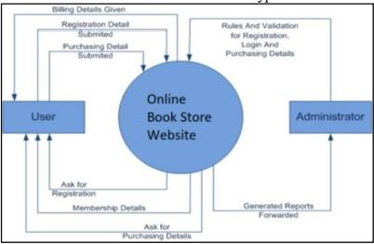

##### Figure 2.1 : System Architecture Diagram

Therefore, there is a need to further study e-books from adoption/usage to how to better manage a large volume of e-books via cloud-based bookstores, forming the basis of this study. By understanding the factors that influence users' continuous usage of cloud- based bookstores, organizations can better manage their e-book collections and provide users with the necessary resources to enhance their reading experiences. Overall, cloud computing has the potential to revolutionize the way we access and utilize computing resources, and with further research and development, it could become the standard model for computing in the future.

##### Continuous Use of Information Systems :

Oliver's Expectation Disconfirmation Theory (EDT) is commonly used to study consumers' repeat-purchase behavior in marketing. However, EDT has some limitations as it assumes that expectations will change based on experience, without an easy way to measure perceived performance. To overcome these limitations, Bhattacherjee developed the Expectation Confirmation Model (ECM) to predict individuals' continuous use of information systems. The ECM incorporates perceived usefulness to explain how an individual's perceived belief affects their repeated use of an IS. The model proposes that users record their original expectations before using an IS and then judge their own perceived usefulness after gaining usage experience. Users then evaluate their original expectations to establish their level of satisfaction with the use of an IS, which drives their decision to continue or discontinue using it. The ECM is a useful tool for studying user behavior and predicting their use of information systems over time.

The Expectation Confirmation Model (ECM) proposed by Bhattacherjee has been widely used to examine the continuous use of an information system. However, researchers have identified some limitations to the ECM in explaining users' ongoing

use of an IS. For instance, a study by Hong et al. (2011) found that perceived enjoyment, which is not accounted for in the ECM, is a significant predictor of users' continuous use of social networking sites. Similarly, a study by Venkatesh et al. (2012) revealed that users' habit is a stronger predictor of continuous use of an IS than expectation confirmation.

Moreover, the existing literature suggests that the ECM may not provide sufficient insights for practitioners to make specific improvements to an IS. Therefore, there is a need for further extensions to the ECM to gain a more comprehensive understanding of users' continuous use of an IS.

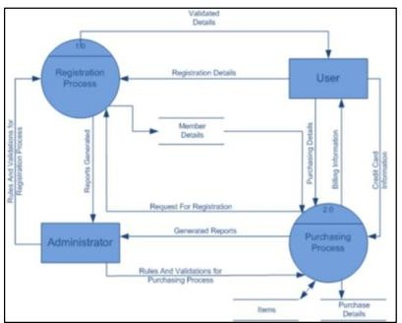

##### Figure 2.2 : UML Design

To address these limitations, researchers have proposed several extensions to the ECM. For instance, the Technology Acceptance Model (TAM) was integrated with the ECM to create the TAM-ECM model, which incorporates perceived ease of use and perceived usefulness as predictors of users' continuous use of an IS (Park & Chen, 2013). Another extension to the ECM is the inclusion of trust as a predictor of users' continuous use of an IS, as proposed by Wang and Emurian (2005).

In summary, while the ECM has been widely used to analyze the continuous use of an IS, it has some limitations, and extensions have been proposed to gain a more comprehensive understanding of users' behavior.

In order to enhance their task performance, individuals often choose a technology tool that best suits their task characteristics. To investigate the impact of technology on task performance, the task-technology fit theory (TTF) is widely used to explore the relationship between task-technology fit and users' performance. TTF refers to how well a technology tool can support individuals in completing their tasks. Individuals are more likely to adopt a technology tool if it closely matches the tasks to be performed. For instance, an accountant may use accounting software such as QuickBooks or Xero for bookkeeping tasks to improve performance.

Various studies have employed the TTF model to examine the performance impact in different contexts and extended it to provide a more comprehensive explanation of the relationship between technology, task, task-technology, and technology utilization. Utilization refers to an individual's behavior of using technology to complete tasks. However, simply utilizing a technology tool does not guarantee better performance. Goodhue and Thompson found that an individual's task performance depends more on TTF than utilization. For example, a salesperson using a customer relationship management (CRM) tool may not perform well if the tool does not provide the necessary features to support the sales process.

Moreover, TTF has been shown to have a significant impact on task performance in various fields, such as healthcare, education, and finance. In healthcare, TTF has been found to influence the use of electronic health records (EHRs) by physicians and nurses, affecting their efficiency and quality of care. In education, TTF has been linked to students' academic performance, where technology tools that match their learning styles can improve their engagement and understanding. In finance, TTF has been identified as a critical factor in the adoption and use of online trading platforms, where a good fit between the technology and traders' strategies can lead to better investment outcomes.

Task-technology fit is a concept that reflects the interaction between the complexity requirements of a task, user abilities, and the functions of information technology or information systems. There are different conceptualizations of a task, but the task- qua-task approach emphasizes the actual materials used in a task, while the task serving as a behavioral requirement approach focuses on the behavior requirements of a task. The task complexity can be integrated into these approaches to emphasize the task's characteristics presented to decision makers.

There are three distinct approaches to defining fit based on the structural contingency theory: fit as internal consistency, fit as interaction, and fit as congruency. However, out of the six fit perspectives proposed by the theory, the last three are not suitable for linking task-technology fit to effective performance in decision-making tasks.

A study showed that higher-level managers especially favor ample media for information processing and communication, implying that the right information technology can support a task best. For example, a cloud-based bookstore can be employed from any time and place, by any user, making it a suitable technology for mobile IS environments. However, it is important to understand the complexity of interwoven factors comprising the user, technology, and environment.

To evaluate technology usage and performance, it is recommended to include user- context characteristics in addition to task and technology characteristics. The task- technology fit can be deconstructed into ideal task-technology fit and individual use context-technology fit, as "task-individual fit" does not consider technology

characteristics. The TTF construct is important in forecasting technology utilization, but it is still a developing concept, and diverse forms of TTF-based models exist.

In a study on information system continuance, perceived technological characteristics were found to be insufficient in increasing continuance intention, highlighting the need to extend the TTF construct to information system continuance by integrating other concepts. Thus, a combination of TTF and ECM is proposed to explain cloud- based bookstore continuance comprehensively.

For example, in the case of a cloud-based bookstore, the ideal task-technology fit would involve a cloud-based system that provides end users with a reliable, customized, and dynamic computing environment, while individual use context- technology fit would consider factors like location, time criticality, functionality, etc. Additionally, the design of informational systems should include the individual use context to account for these limitations.

Overall, understanding the task-technology fit and its deconstruction into ideal task- technology fit and individual use context-technology fit is crucial in determining the effectiveness of information technology or information systems in supporting decision-making tasks. By considering various factors such as the user, technology, and environment, a comprehensive understanding of the TTF construct can be achieved, leading to improved technology utilization and performance.

Cloud computing has become an integral part of the modern-day digital infrastructure. With more and more businesses embracing the cloud, there are a number of cloud service providers that have emerged in the market. In this article, we will discuss some of the top cloud providers like AWS, Google Cloud, Azure, and others, their market shares, and recent trends.

Software as a Service (SaaS) is the highest level in cloud computing services, and it originated when the internet started gaining more prominence. At this level, organizations provide applications as a service to customers, and users can access the software applications via the internet without having to download or install them locally. Initially, SaaS emerged from the host functions of the Platform as a Service, and it has grown to offer numerous options to both businesses and individuals, including educational institutions. While SaaS services offer geographical flexibility, data confidentiality can be a concern since data is directly shared over the internet. As a result, Virtual Private Networks (VPNs) are frequently used to encrypt data sent over the internet, ensuring that user and SaaS data is kept secure and confidential.

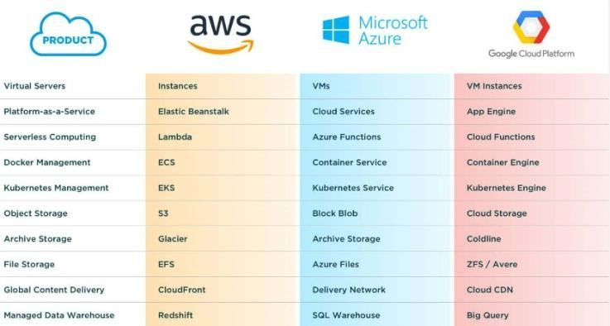

**Figure 2.3 : Comparing Different Cloud Platforms**

**AWS (Amazon Web Services)**

Amazon Web Services (AWS) is a cloud computing platform offered by Amazon.com. AWS offers a broad range of services including compute, storage, database, analytics, machine learning, and more. Some of the popular services offered by AWS include Amazon EC2, Amazon S3, Amazon RDS, Amazon Aurora, Amazon DynamoDB, Amazon Redshift, and Amazon EMR.

AWS is the market leader in the cloud computing space with a market share of over 30%. According to Synergy Research Group, AWS generated over $40 billion in revenue in 2020. AWS's dominance in the cloud computing market can be attributed to its wide range of services, global infrastructure, and strong customer support.

**Recent trends:**

AWS has been heavily investing in artificial intelligence (AI) and machine learning (ML) technologies, with the launch of services like Amazon SageMaker, Amazon Rekognition, and Amazon Polly.

AWS is also making strides in the edge computing space with the launch of AWS Outposts, a service that enables customers to run AWS infrastructure on-premises.

#### Google Cloud

Google Cloud is a cloud computing platform offered by Google. Google Cloud offers a range of services including compute, storage, database, analytics, machine learning, and more. Some of the popular services offered by Google Cloud include Google

Compute Engine, Google Cloud Storage, Google Cloud SQL, Google BigQuery, and Google Cloud AI Platform

Google Cloud is the third-largest cloud provider with a market share of around 9%. According to Synergy Research Group, Google Cloud generated around $6 billion in revenue in 2020. Google Cloud's strengths lie in its strong data analytics capabilities and its integration with Google's other services.

**Recent trends:**

Google Cloud has been investing heavily in the healthcare sector, with the launch of services like Healthcare API and Cloud Healthcare Data Processing.

Google Cloud is also focusing on sustainability, with the launch of Carbon-free Regions, a service that enables customers to run their workloads in regions powered by carbon-free energy sources.

#### Azure (Microsoft Azure)

Azure is a cloud computing platform offered by Microsoft. Azure offers a wide range of services including compute, storage, database, analytics, machine learning, and more. Some of the popular services offered by Azure include Azure Virtual Machines, Azure Blob Storage, Azure SQL Database, Azure Cosmos DB, and Azure Machine Learning.

Azure is the second-largest cloud provider with a market share of around 20%. According to Synergy Research Group, Azure generated around $20 billion in revenue in 2020. Azure's strengths lie in its strong enterprise offerings and its close integration with Microsoft's other services.

**Recent trends:**

Azure has been focusing on hybrid cloud solutions, with the launch of Azure Arc, a service that enables customers to manage their on-premises, multi-cloud, and edge deployments using Azure management tools.

Azure is also making strides in the quantum computing space, with the launch of Azure Quantum, a service that enables customers to experiment with quantum algorithms and technologies.

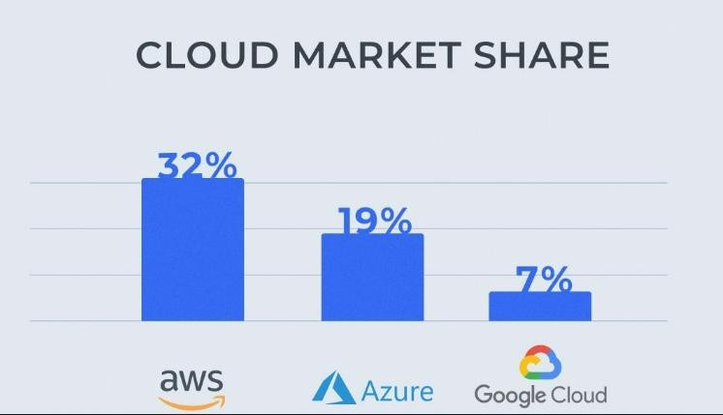

##### Figure 2.4 : Cloud Market Share

**Existing features provided by online bookstores typically include:**

Search functionality: Customers can search for books based on various criteria such as author, title, genre, or ISBN.

Recommendations: Online bookstores often suggest books to customers based on their previous purchases or browsing history.

Reviews and ratings: Customers can leave reviews and ratings for books they have purchased or read, which helps others to make informed decisions.

Preview or sample chapters: Many online bookstores allow customers to read a few pages of a book before purchasing it.

E-books and audiobooks: Many online bookstores offer e-books and audiobooks in addition to physical books.

Customer support: Online bookstores typically provide customer support through email, chat, or phone.

**Here are some more ideas for easy-to-add features for an online bookstore:**

Wishlists: Allow customers to create wishlists of books they want to buy in the future, making it easier to keep track of books they're interested in.

Related items: Show related books or items on the book detail page to help customers find other books they might be interested in.

User-generated content: Allow customers to contribute content such as book reviews,

ratings, or recommendations.

Gift cards: Allow customers to purchase gift cards, which they can give to friends or family members to buy books from the online bookstore.

Discounts and promotions: Offer special discounts and promotions to customers who subscribe to the bookstore's email newsletter.

Book bundles: Create book bundles or packages that offer multiple books for a discounted price.

Local bookstores: Highlight local bookstores in the area, so customers can support their local bookstores while browsing online.

Reading challenges: Introduce reading challenges, where customers can set goals for how many books they want to read and track their progress.

Author events: Promote author events such as book signings, Q&A sessions, or live talks, which customers can attend online.

Social media integration: Allow customers to share their favorite books or reviews on social media platforms like Twitter or Facebook.

Personalized recommendations: Develop a recommendation engine that uses machine learning to suggest books to customers based on their reading history and preferences.

Book clubs: Introduce a feature that allows customers to create book clubs and discuss books with other readers.

Bookmarks and highlights: Create a feature that allows customers to bookmark pages and highlight sections of a book they are reading.

Virtual bookshelf: Develop a feature that allows customers to create a virtual bookshelf to organize their purchases and track their reading progress.

Collaboration with authors: Develop a feature that allows authors to interact with readers through Q&A sessions or book signings.

These are just a few ideas, and there are many other features that could be introduced to make an online bookstore more engaging and useful for customers.

These are just a few more ideas to get you started. Depending on the specific online bookstore you are developing, you may need to tailor these ideas or come up with different features that are relevant to your customers.

**Table 1 : Existing Features and the features that can be implemented**

|  |  |
| --- | --- |
| **Existing Features** | **Features that can be implemented** |
| Search functionality | Social media integration |
| Recommendations | Personalized recommendations |
| E-books and  audiobooks | Virtual bookshelf |
| Advanced search filters (e.g. by publication date, format, or Wishlist  language) | Wishlist |
| Recently viewed  items Related items | Related items |
| New releases lists | Gift cards |
| Categories or genres | Discounts and promotions |
| Top-rated books | Book bundles |
| Personal user profile | Local bookstores |

# Chapter 3 : System Design

### DFD Diagram

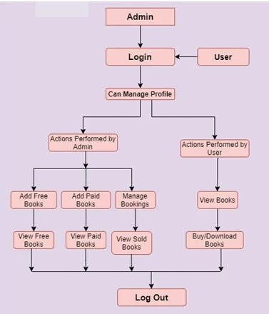

**Figure 3.1 : DFD Diagram**

### Use Case Diagram

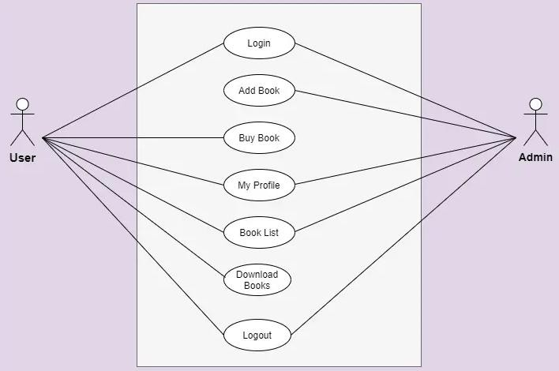

##### Figure 3.2 : Use Case Diagram

The figure above shows the use case diagram of Online Cloud Enabled Bookstore System. There are some functions provided by the system.

* Login

Login function is needed to identify whether the user is client or admin. Different roles can perform different tasks.

* Add Book

This feature can only be accessible by the admin because they have the rights to add books in the system.

* Buy Book

This feature is only given to user side because only they can buy the products from the online system.

* My Profile

Both user and admin have their profile on the system to add books or buy from it.

* Book List

This feature is provided to both user and admin. Admin can see the book lists which are added on the system and user can see the list of books which are purchased and downloaded by them.

* Download Books

Only users has given this permission so they can download the required books of their need.

* Logout

Both have logout features so they can logout from the system when the work is done.

### User Interface Design

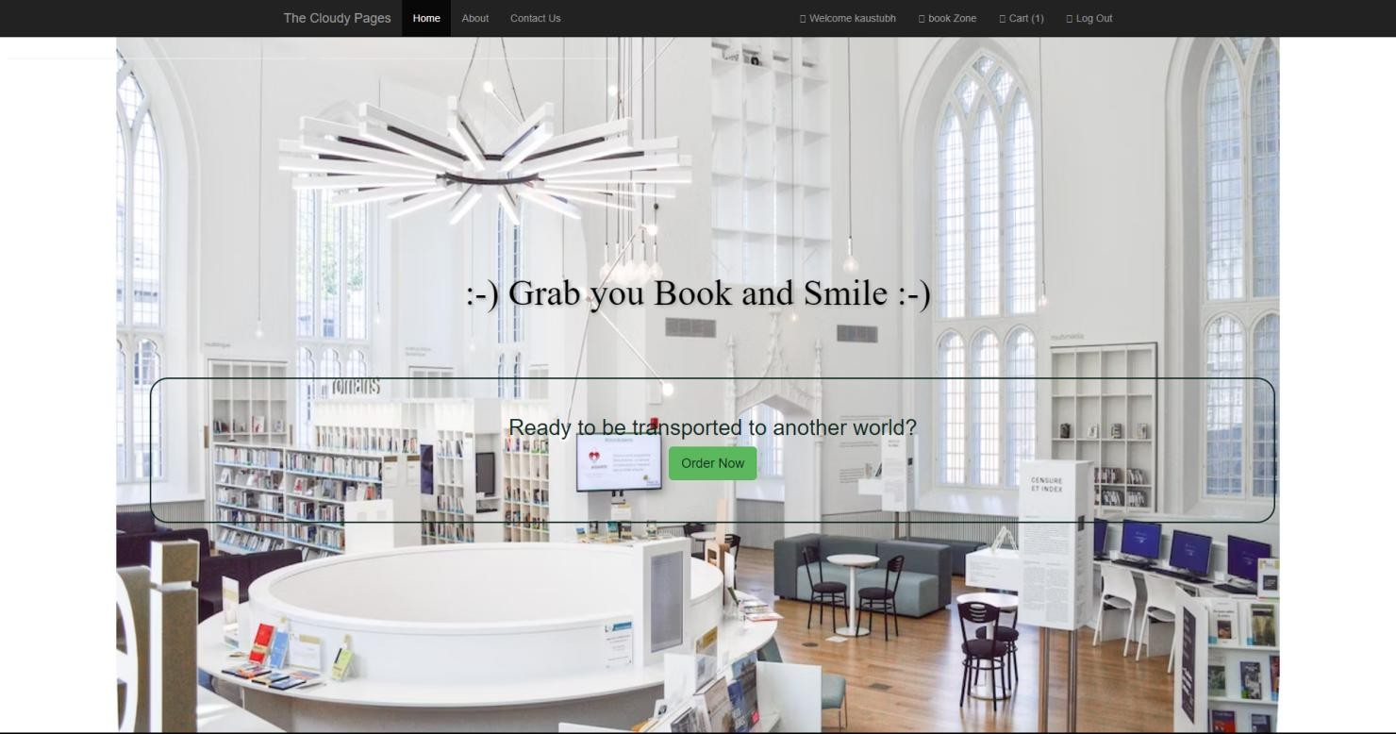

##### Figure 3.3 : Home Page

This is the home page of the system. The customers can click on the place order button to view the books. The staff and chef can click on the admin login button to login to the system.



##### Figure 3.4 : Welcome Page1

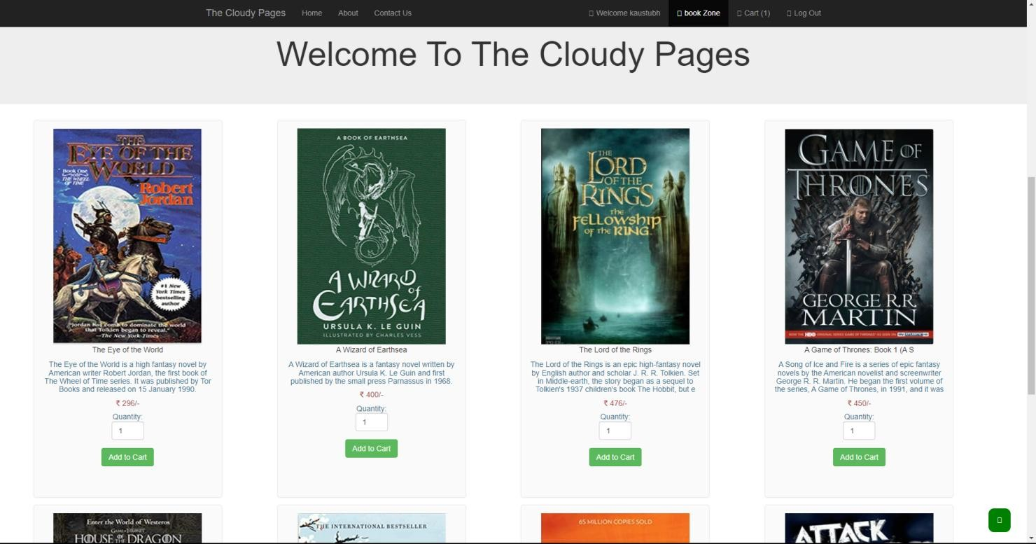

**Figure 3.5 : Welcome Page2**

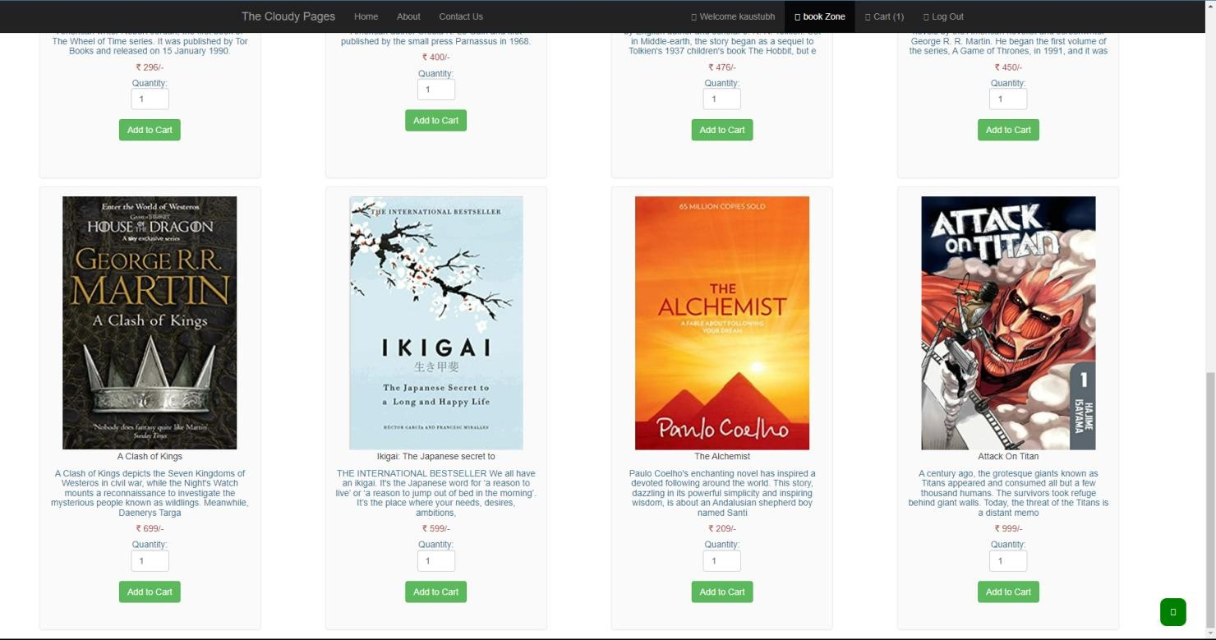

##### Figure 3.6 : Welcome Page3

After the customers click the place order button, this page will be displayed to the customers. The customers can choose the category to view the books. If the customers wish to order the books, they can click on the order button.

Let’s say we want to order any of the two things from the list, the items are added to the cart. Here is the picture of our cart.

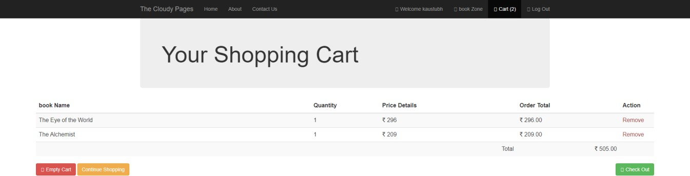

##### Figure 3.7 : Shopping cart

Here if the user checks out, our system will provide the user with two choices:-

* + 1. Pay Online
    2. Cash On Delivery

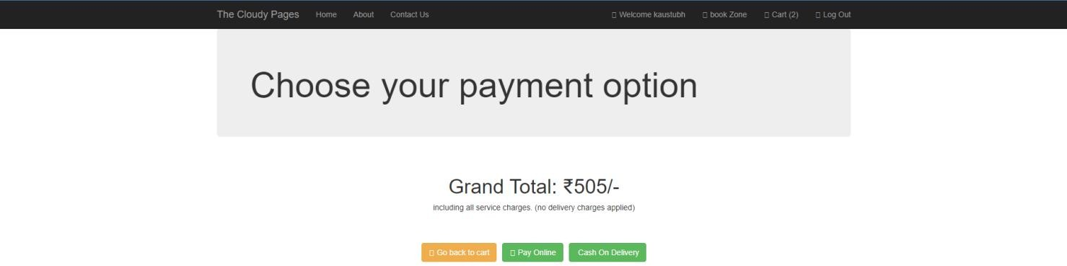

##### Figure 3.8 : Payment Options

If the user opts for pay online, we will ask the user to give his credit card details for further transactions, here we ask the user for their credit card number, expiry month and year, cvv and Name on the card.

We also provide a option for saving card for fast payment.

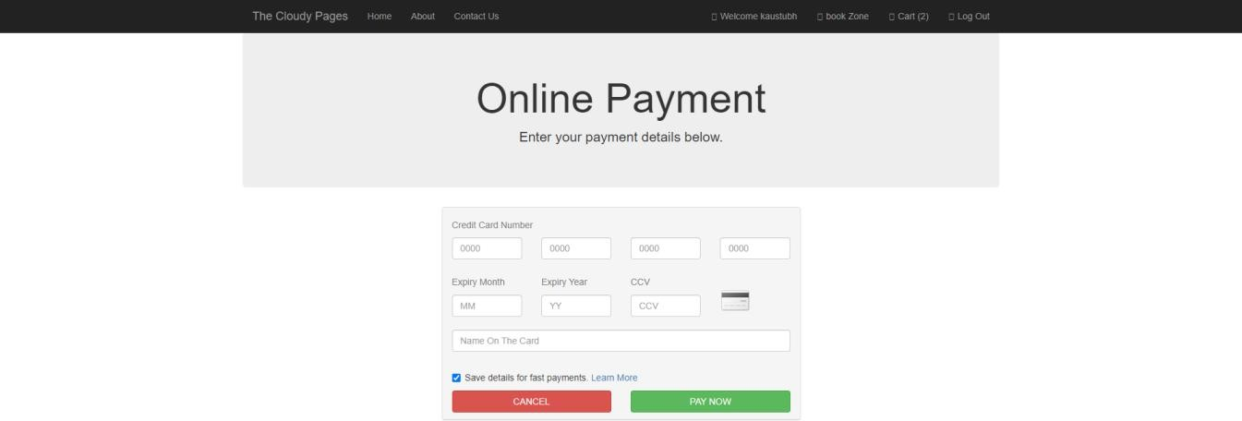

##### Figure 3.9 : Payment Screen.

And after this the user’s order will be confirmed and will be processed.

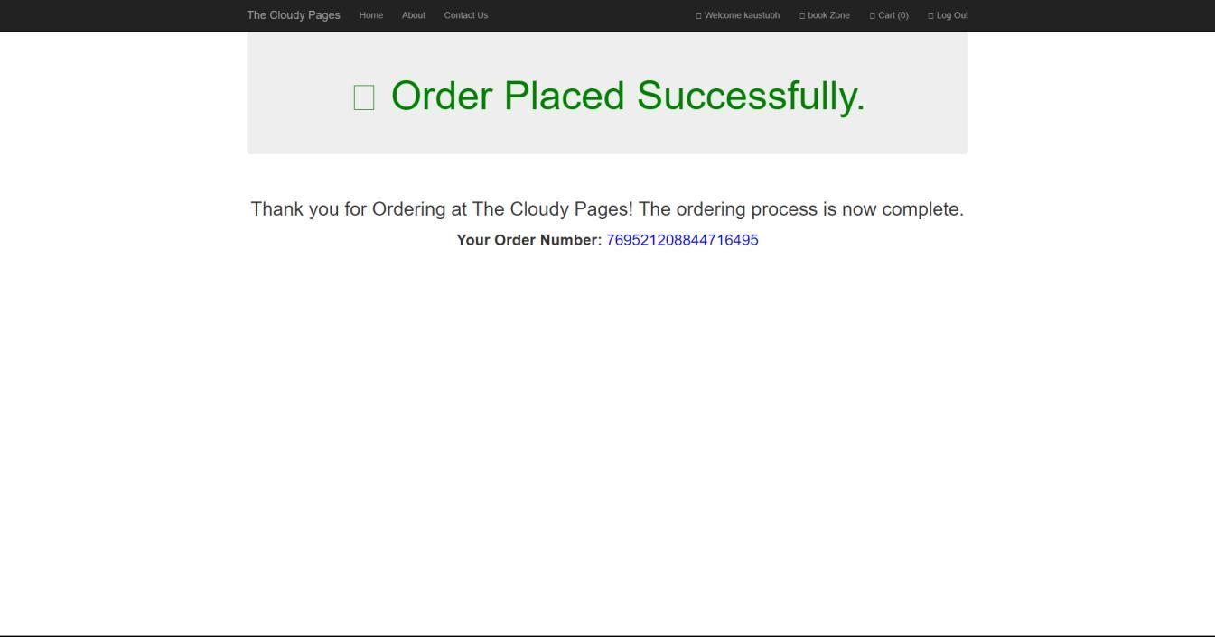

### Login Area

##### Figure 3.10 : Order Confirmation Screen

Here we have given the option to select you login as Customer or as a Manager.

The customer can only order the books while the manager can manage all the stuffs happening like managing the orders, adding and deleting the books etc.

### Customer Login

Here the customer can log himself in the bookstore, and for the ones who are ordering for the first time we have provided a create new account option to log them into our database.

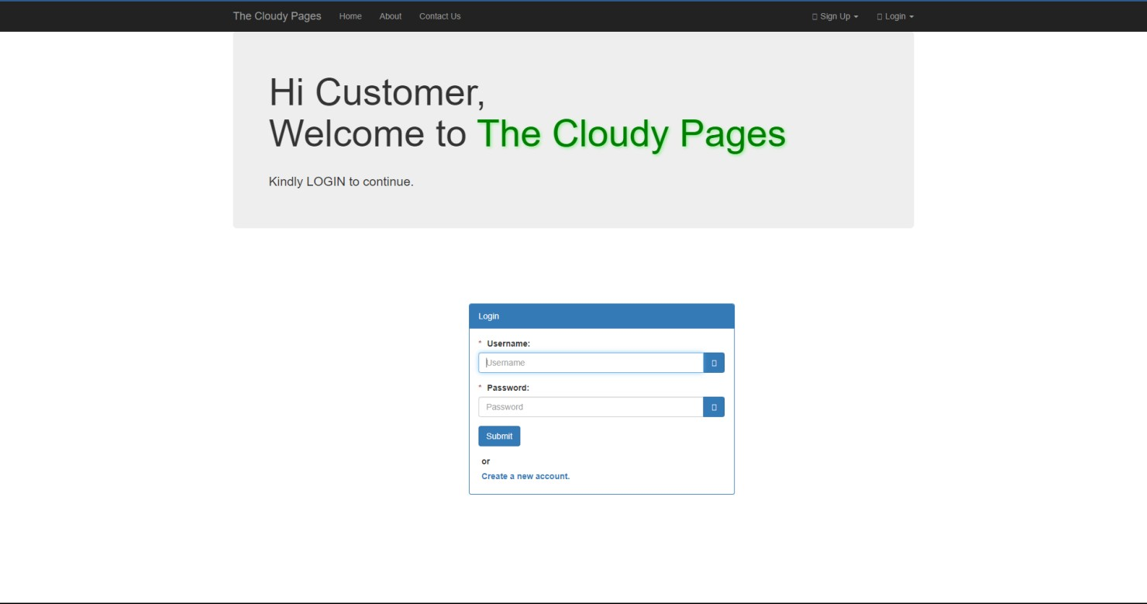

##### Figure 3.11 : Customer Login

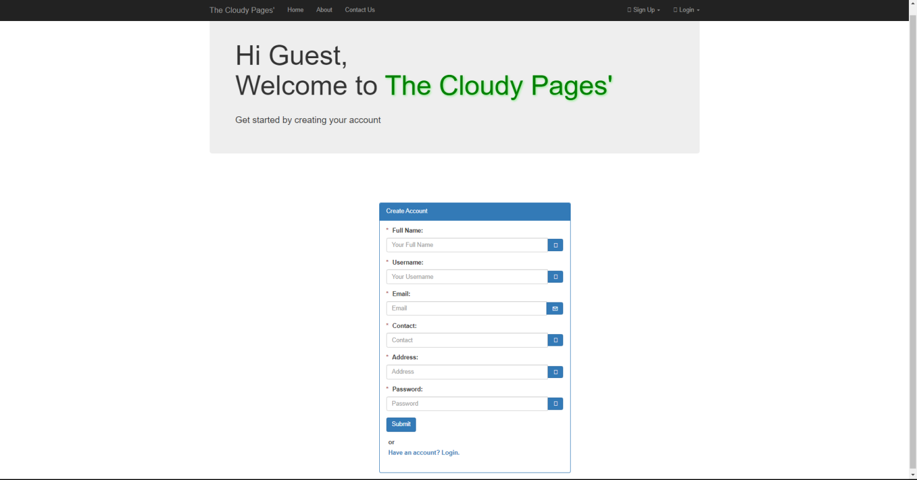

**Figure 3.12 : Customer Sign in**

### Manager Login

Here the manager will access the bookstore and will manage the stuffs happening behind.

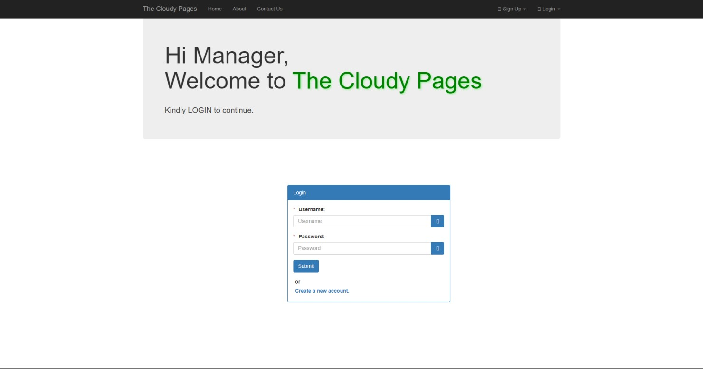

##### Figure 3.13 : Manager Login

We also allow the new manager to take over, hence we provided a section where a new manager can create his login Id.

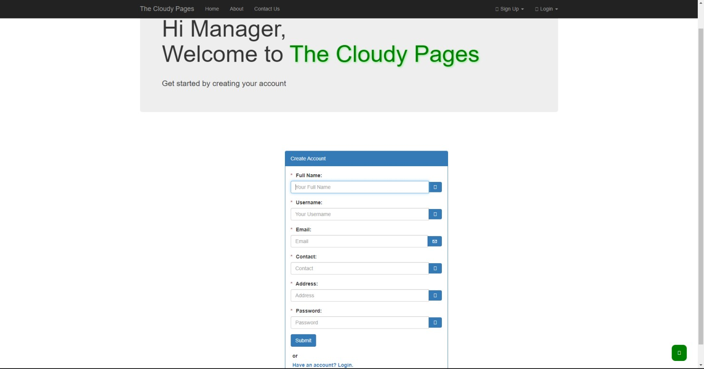

##### Figure 3.14 : Manager Sign Up

When a manager logs in the system the first thing he sees is the My Bookstore page.

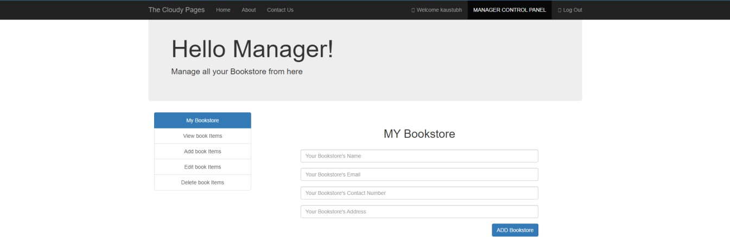

##### Figure 3.15 : My Bookstore

Here the manager can change the Bookstore name, email, contact number and address.

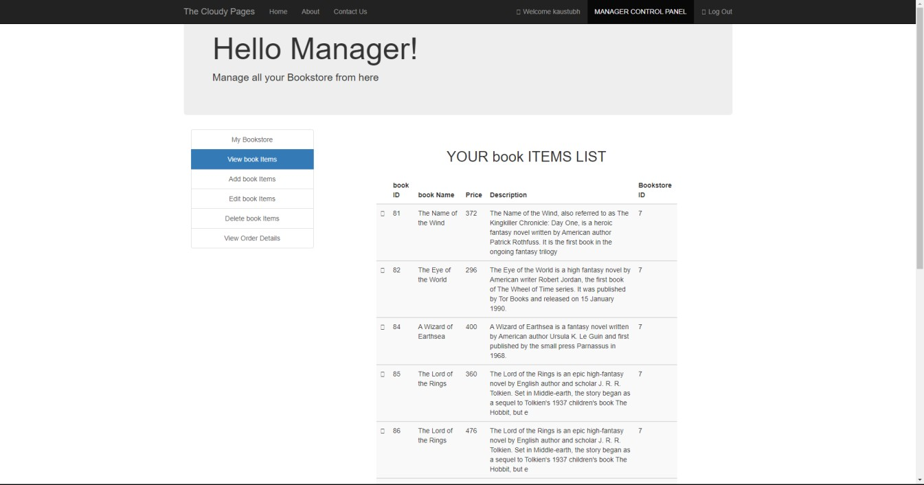

##### Figure 3.16 : View Book Items

Here all the book items added by the manager will show up.

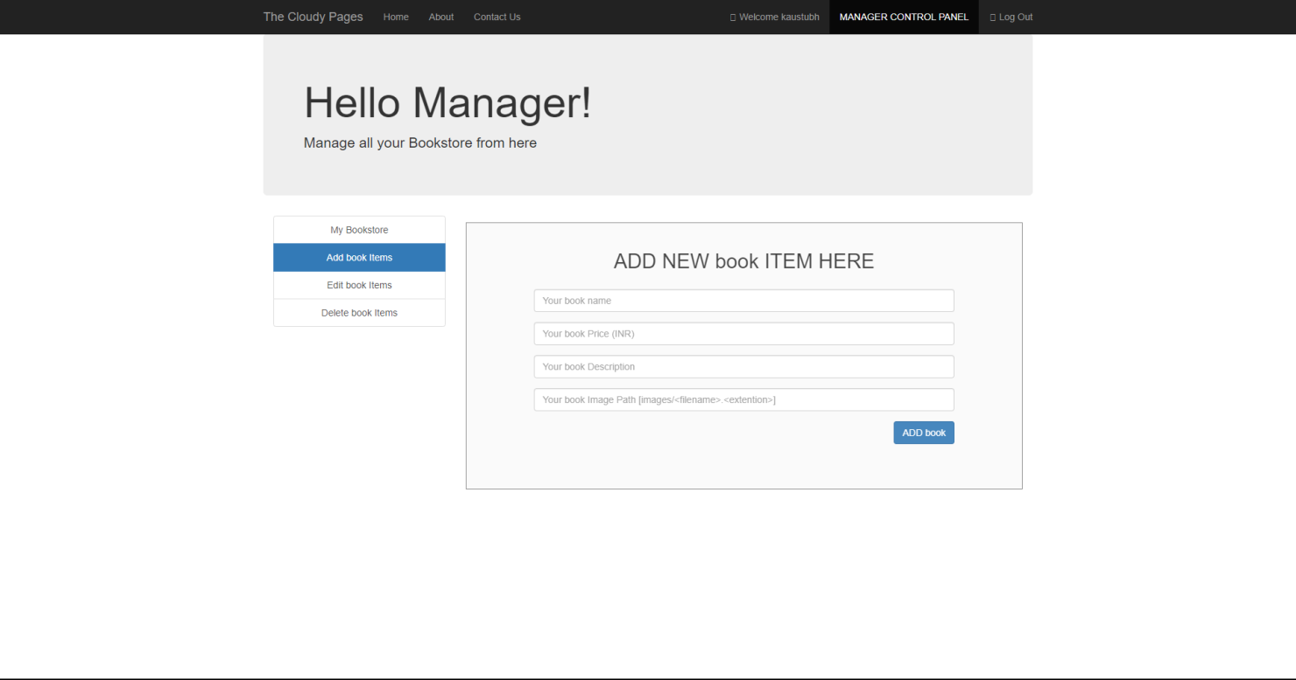

**Figure 3.17 : Add Book Items**

Here the manager can add more book items to the book list.

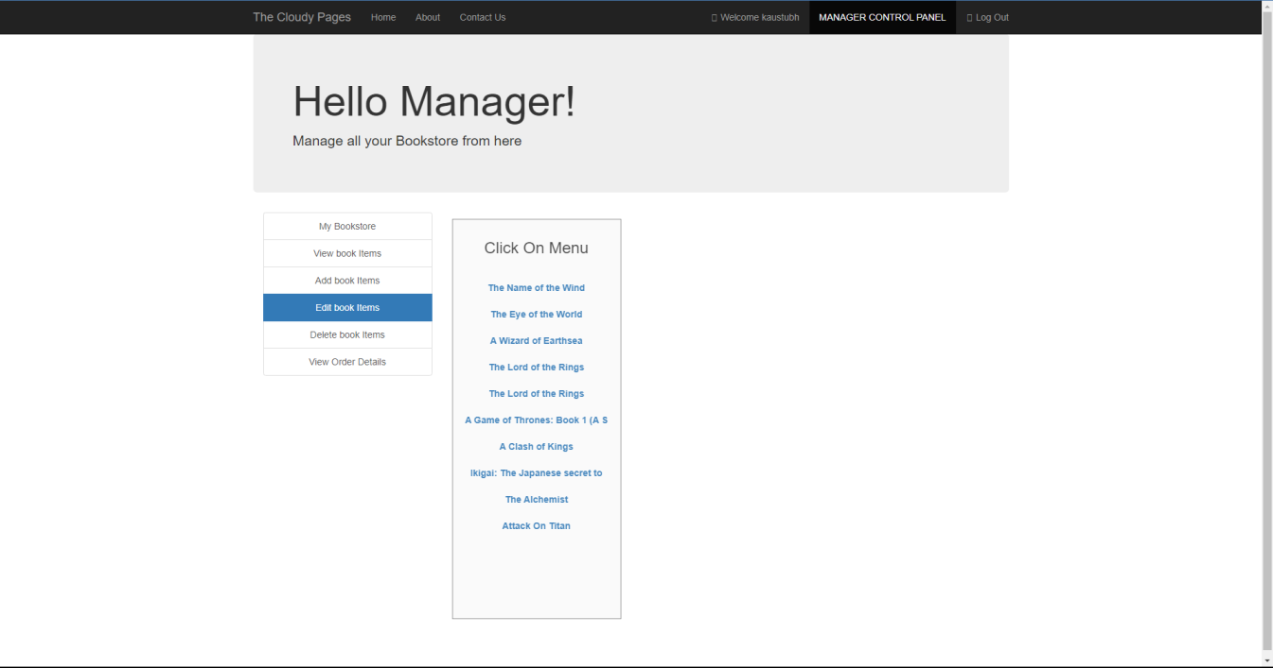

##### Figure 3.18 : Edit book items

Here the manager can edit the book items in the book list list.

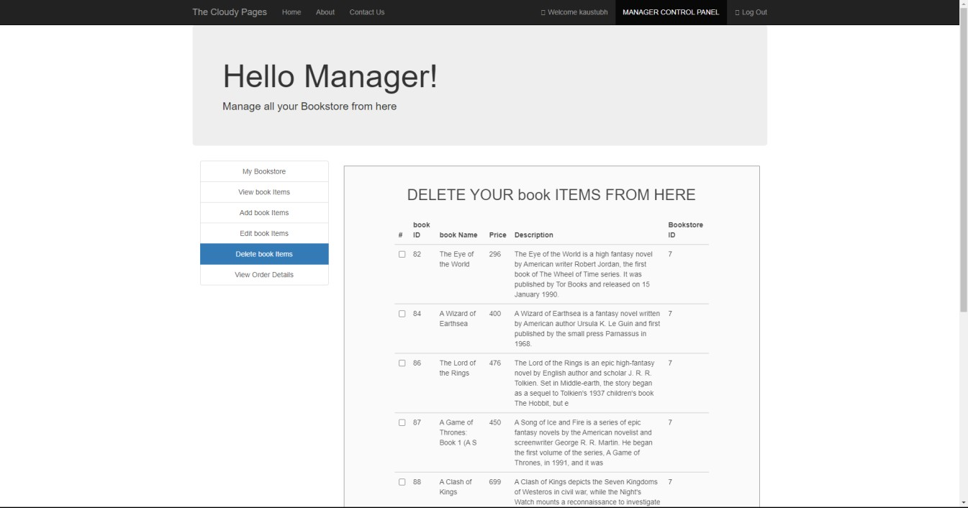

##### Figure 3.19 : Delete book Items

Here the manager can delete the book items from the main book list.

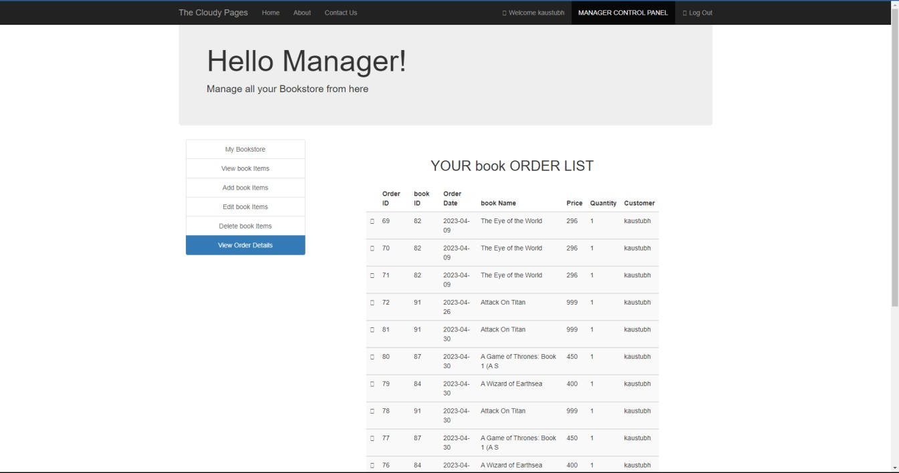

##### Figure 3.20 : Order History

Here the manager can see the full history of the items ordered.

We have stored all these images used in this project in a folder names Images

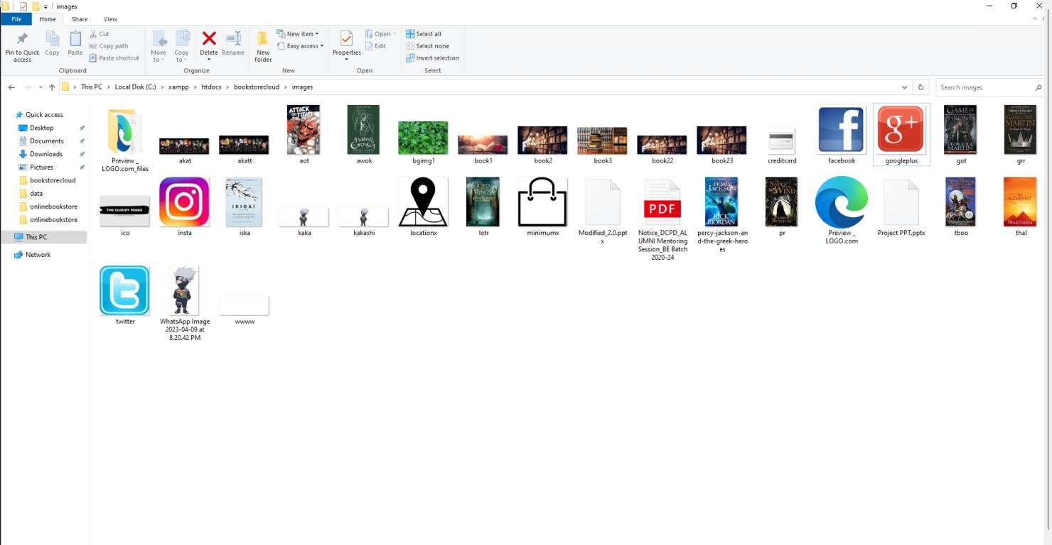

##### Figure 3.21 : Images Folder



**Figure 3.22 : Server on Amazon AWS**

This shows the server running on the Amazon AWS EC2 Instance (Cloud hosting)

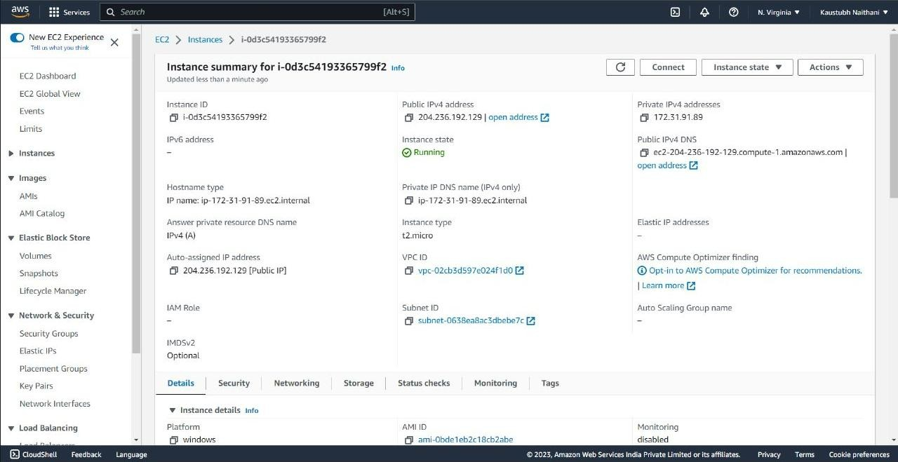

##### Figure 3.23 : EC2 instance details

Here on the console we see all the details of the instance, like the public and private ip address, dns , and other options to view the networking , security , storage details

, and also tools for monitoring the server.

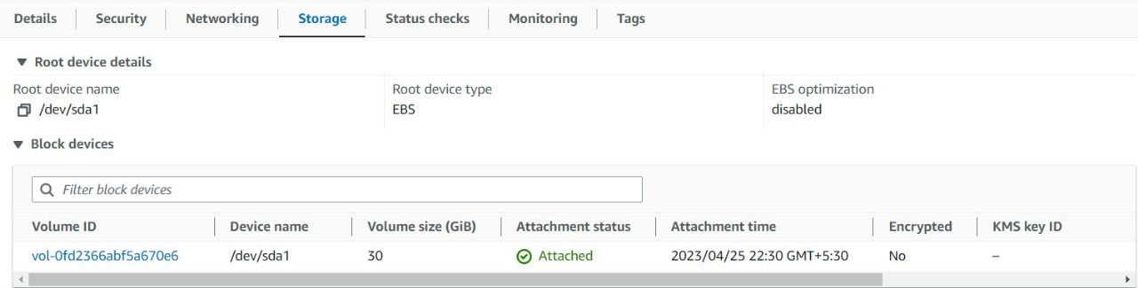

##### Figure 3.24 : The storage details

Amazon EC2 provides various storage options including Elastic Block Store (EBS) for persistent block-level storage, Instance Store for temporary instance storage, and Amazon Elastic File System (EFS) for scalable network file storage.

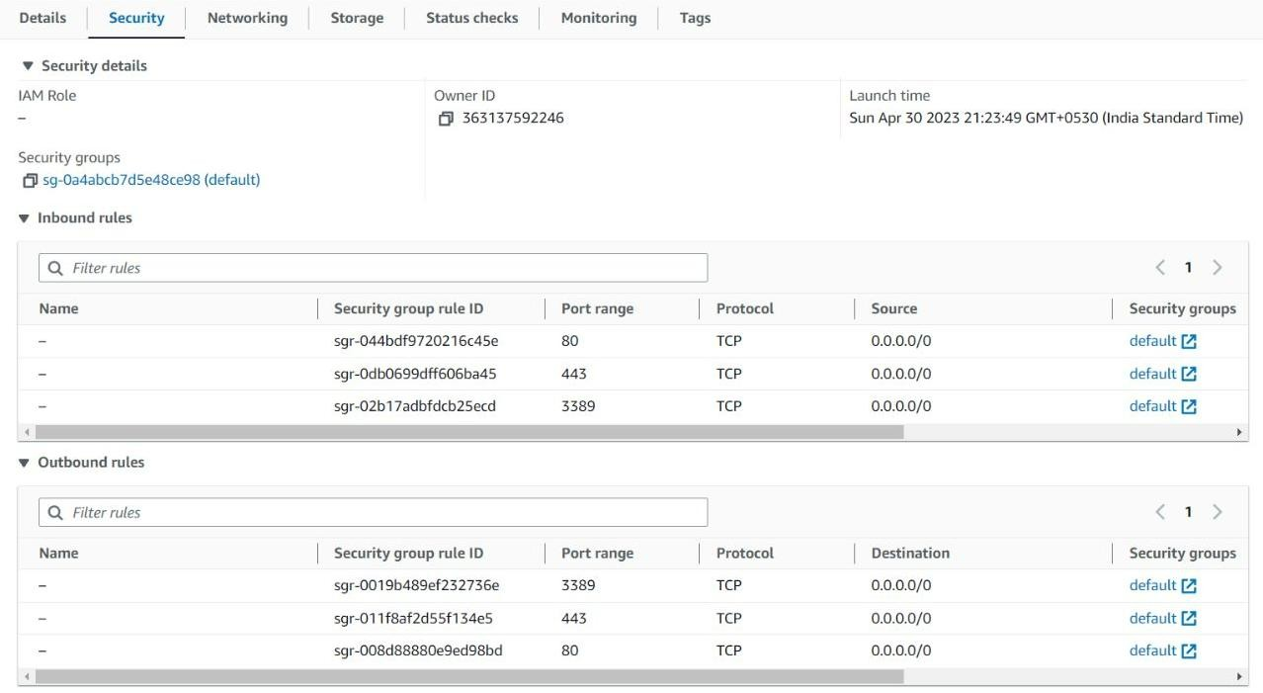

##### Figure 3.25 : Security Details

Amazon EC2 offers various security measures such as Virtual Private Cloud (VPC), Security Groups, Network ACLs, Identity and Access Management (IAM), and encryption options to secure instances and data at rest and in transit.

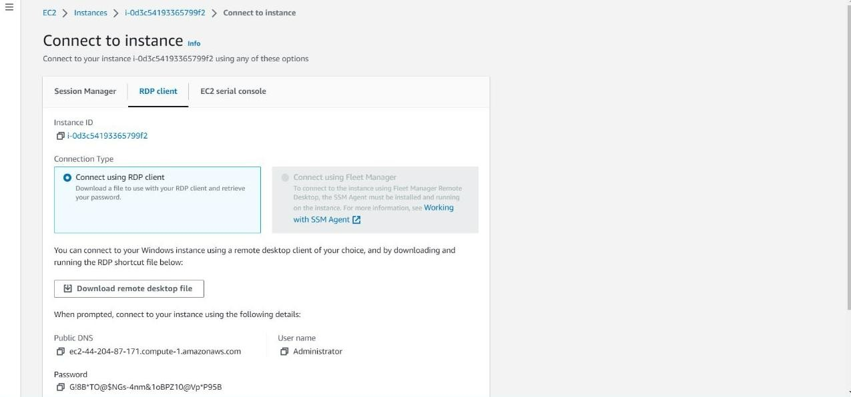

##### Figure 3.26 : Connecting to Instance using RDP

To connect to an Amazon EC2 instance using Remote Desktop Protocol (RDP), users need to create a Windows instance and configure its security group and firewall settings to allow RDP traffic. Then, they can use a Remote Desktop client to connect to the instance using its public IP address.

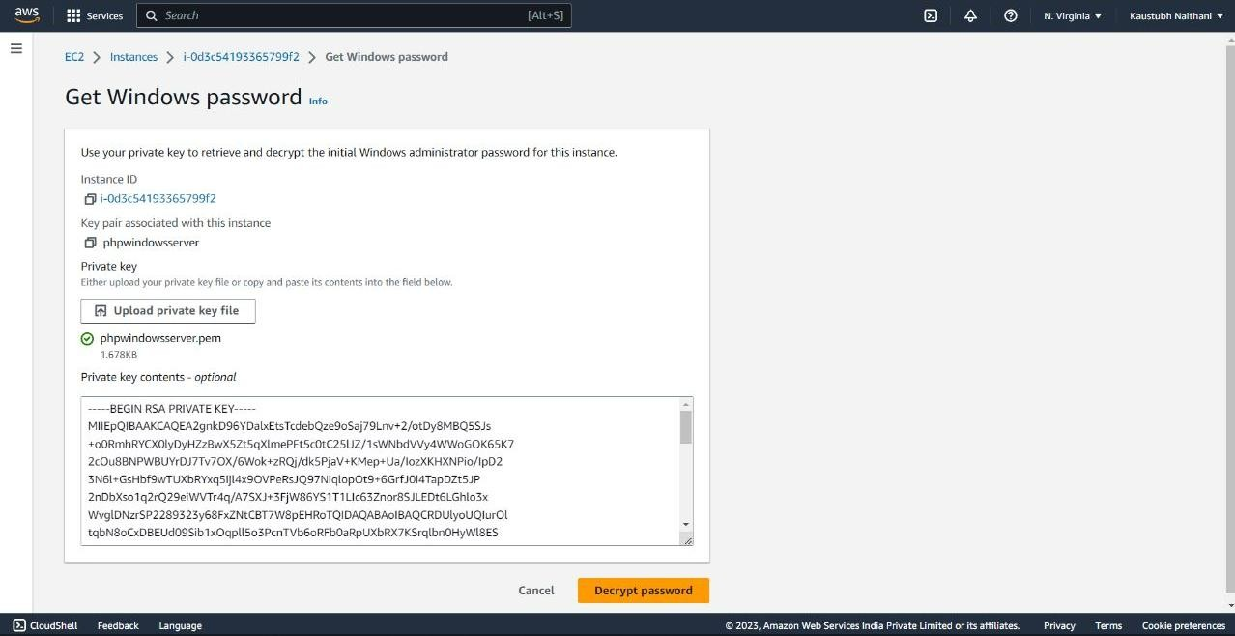

##### Figure 3.27 : Password for the windows server

When creating a Windows instance on Amazon EC2, users can generate a random password or provide their own. The password is encrypted with an RSA key pair, and users can retrieve it using the EC2 console or the AWS CLI.

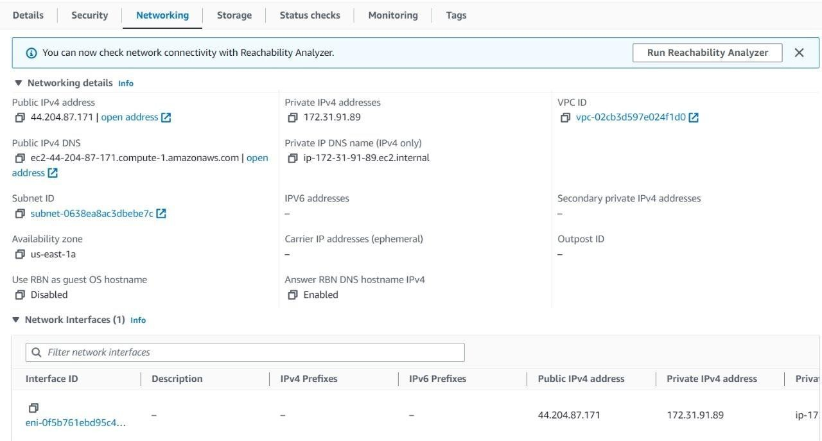

##### Figure 3.28 : Networking Information of the instance

Amazon EC2 instances can be launched in a Virtual Private Cloud (VPC), providing users with control over the network environment. Users can configure subnets, route tables, and security groups, and connect their VPC to other networks using VPN, Direct Connect, or AWS Transit Gateway.

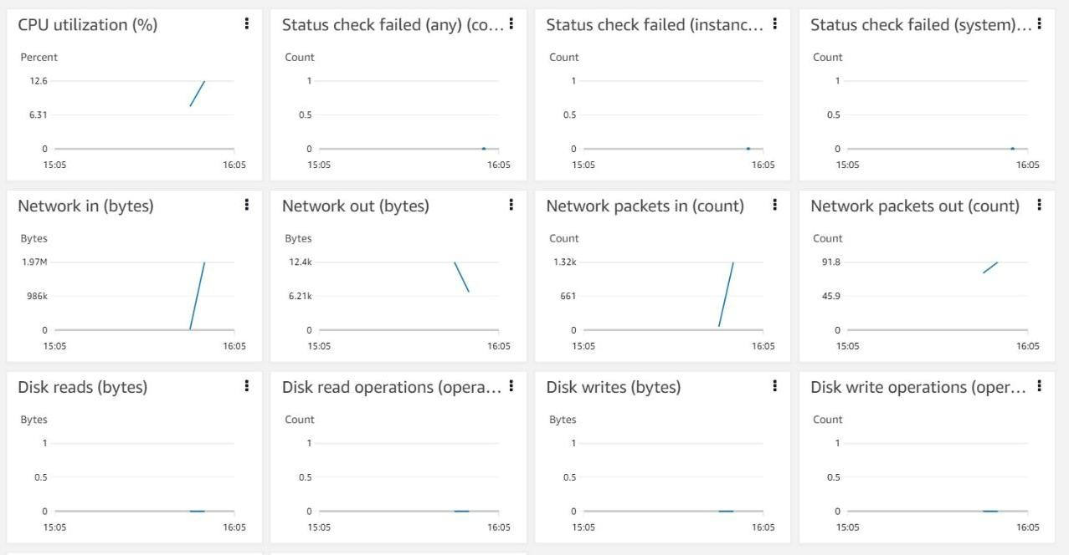

##### Figure 3.29 : Server Statistics of the instance

Amazon EC2 provides detailed server statistics such as CPU utilization, network traffic, disk I/O, and instance status via CloudWatch metrics. Users can also monitor logs and events using CloudWatch Logs and CloudTrail. Third-party monitoring tools like Datadog and New Relic are also available.

* 1. **Database**

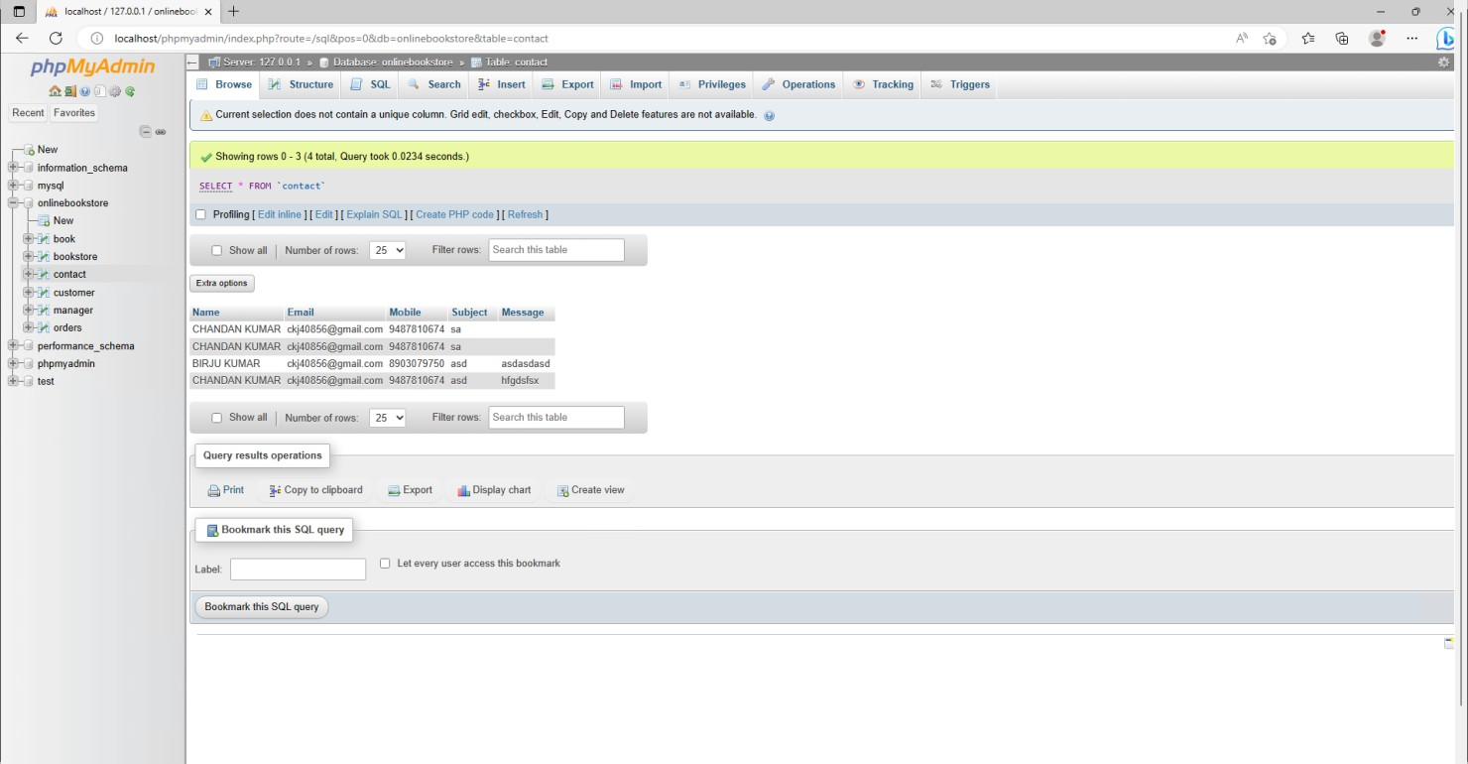

##### Figure 3.30: Database of customer detail

This is the table shows that have the contact of our clients and their details. It gets updated as a new client gets attached to our service and the table gets append and data is circulated among the whole database.

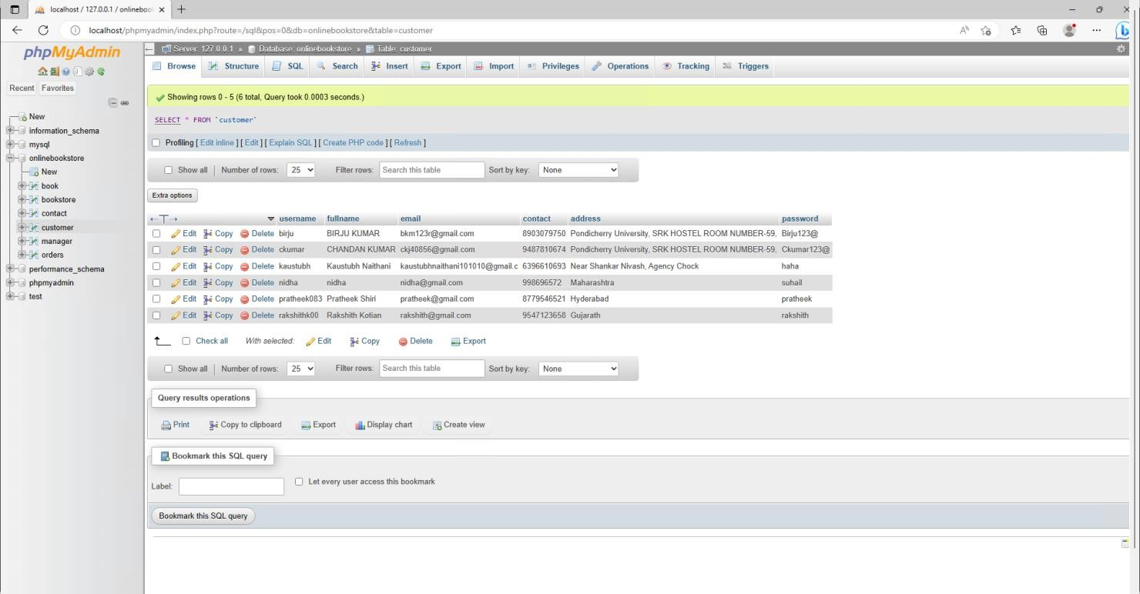

##### Figure 3.31 : Table of customer login credentials

This Data table here describes the Customer login details, password and their personal information.

The database gets appended by itself as the new customer sign up on the login page of our website and credentials are saved over here and can be used by the user to login to website and order gets linked by their credentials.

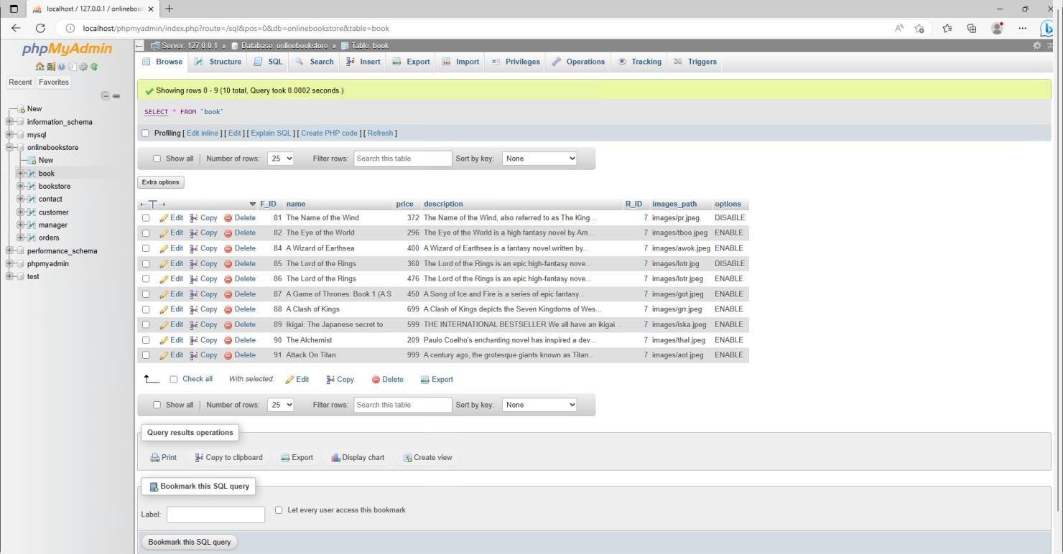

##### Figure 3.32 : List of all books in database

This database table hereby describes the list of all the books added by the managers individually. This also has description and the book price and the availability of the books can be managed personally by the manager.

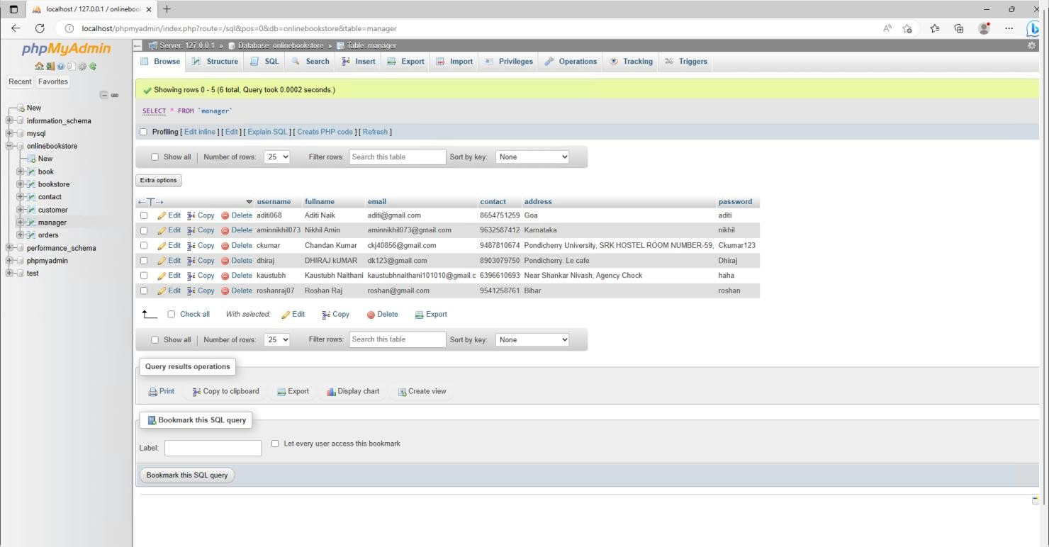

##### Figure 3.33 : Table of manager login credentials

This contains the Manager details and their login credentials also has some of their personal information. This is Managed by the Admin can be appended and used for login for the manager info.

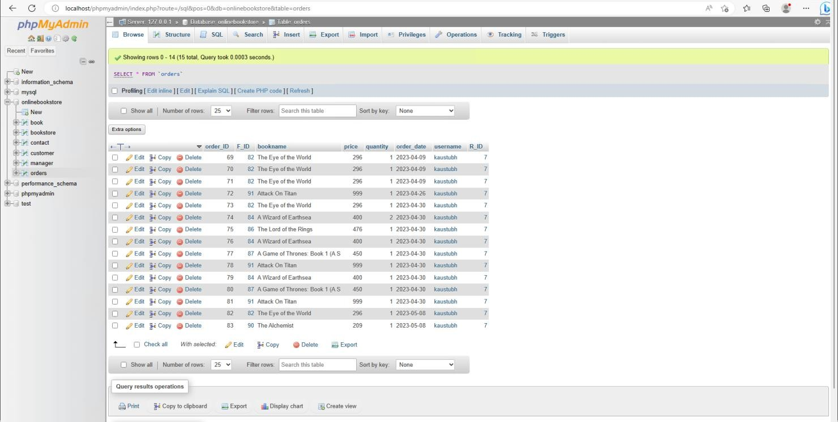

##### Figure 3.34 : Database of books ordered

This hereby is the auto generated table as soon as the order is placed by the user and gets confirmed by the manager. This table contains the bill details of the orders and personal information of the customer.

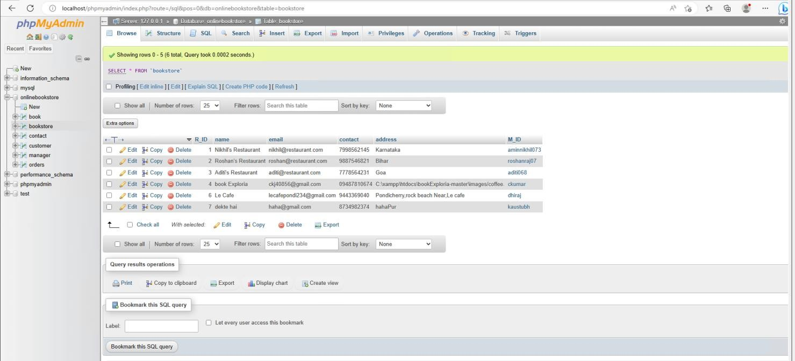

##### Figure 3.35 : Table of individual user bookstore

This Database table describes the Book’s Author Details their location ,number and their personal information and it is managed by the Admin can be appended . This can be edited from the database server.

## Chapter 4 Methodology

### Methodology Used

##### Requirement gathering:

This phase of the methodology involves gathering the requirements for the cloud-enabled bookstore system. Requirements gathering can be done through a variety of methods, such as user interviews, surveys, and studying existing systems in the market. The requirements gathered will include the features and functionality that the system must have to meet the needs of the customers. The system should allow customers to browse and purchase books online, and should include features such as real-time inventory management, personalized recommendations based on customer preferences, and easy payment options.

##### System design:

The system design phase involves creating a plan for how the system will be built. This includes designing the database schema, user interface, and cloud infrastructure. The database schema will define the structure and relationships between the data elements that will be stored in the database. The user interface will determine how the system will look and feel to the user, including the layout, color scheme, and user flow. The cloud infrastructure will include the services and resources needed to run the application in the cloud, such as virtual machines, storage, and networking.

##### Development:

In this phase, the system will be developed using appropriate technologies and programming languages. The database will be developed using SQL or NoSQL database technologies such as MySQL or MongoDB. The user interface will be developed using front-end web technologies such as HTML, CSS, and JavaScript, and web frameworks such as React, Angular, or Vue. The cloud infrastructure will be developed using cloud services such as Amazon Web Services (AWS) or Microsoft Azure.

##### Testing:

Once the development is complete, the system will be tested to ensure that it meets the requirements and is free from any bugs or errors. Testing will include unit testing, integration testing, and system testing. Unit testing involves testing individual components of the system, while integration testing tests how these components work together. System testing will test the system as a whole, including its performance and usability.

##### Deployment:

Once testing is complete, the system will be deployed on a cloud platform such as Amazon Web Services or Microsoft Azure. The cloud infrastructure will be configured, the database will be set up, and the application code will be deployed to the cloud environment.

##### Maintenance:

After deployment, the system will be maintained by performing routine updates, security checks, and backups. This will ensure that the system continues to function properly and remains secure. Maintenance may also include adding new features or making changes to existing ones, based on feedback from users or changes in the market.

This methodology provides a structured approach for developing a cloud-enabled bookstore system, from gathering requirements to deploying and maintaining the system. It emphasizes the importance of user-centered design, testing, and ongoing maintenance to ensure that the system meets the needs of customers and is secure and reliable.

### Tools

* PHP, HTML, CSS

These advances are utilized to fabricate the framework. PHP and HTML are utilized to construct the connection point of the framework and fabricate the usefulness of the framework. CSS is utilized to characterize styles of the framework.

* XAMMP

XAMPP is a free and open-source cross-platform web server solution stack package. This software is used to connect to Apache and MySQL.

* phpMyAdmin

phpMyAdmin is an open source and free administration tool for MySQL. This tool is used to insert the database.

* Visual Paradigm Community Edition Visual Paradigm Community Edition is a UML CASE Tool. This software is used to draw the use case diagram and activity diagram.
* VS Code

VS Code is a free and open-source text and source code editor. This software is used to code the system.

### Requirement

* XAMMP ControlPanelVersion3.2.3
* phpMyAdminVersion4.8.5
* Laptop OperatingSystem:Windows10

Processor: [Intel(R)Core(TM)i5-5200UCPU@2.20GHz](mailto:Intel(R)Core(TM)i5-5200UCPU@2.20GHz) 2.19GHz

### Implementation and Testing

The execution of the framework will be begun after the finish of the framework plan. The design of the information base will first and foremost form during improvement stage. Then, at that point, the server side and client side likewise worked to permit the correspondence among clients and staff. During the testing stage, scarcely any experiments are completed to test the framework. This is to ensure the framework is dependability.

Unit Testing1: Login

Test Objective: To ensure the user able to login with valid name and password.

##### Table 2: Login

|  |  |  |
| --- | --- | --- |
| Input | Expected output | Actual output |
| Login by entering correct name and  password. | The system let the user login. | The user login successfully. |
| Login by entering wrong password. | The system does not allow the user to  login. | The user can’t login to the system. |
| Login by does not enter any value. | The system does not allow the user to  login. | The user can’t login to the system. |

Unit Testing2: Add new book

Test Objective : To ensure the staff able to add new books into the system.

##### Table 3: Adding New Books

|  |  |  |
| --- | --- | --- |
| Input | Expected output | Actual output |
| Enter all the information of the books | The books information is stored into the  database. | The book information is stored into the database and the user can view the book in the list. |
| Enter few information of books | The books information will not be stored in the  database. | The system does not allow the user to add new books. |
| Click Save button without entering any information | The book information will not store into the  database. | The system does not allow the user to add new book. |

Unit Testing3: Add new category

Test Objective: To ensure the staff able to add new category into the system.

##### Table 4: Adding New Category

|  |  |  |
| --- | --- | --- |
| Input | Expected output | Actual output |
| Enter the information of the category | The category information is stored into the database. | The category information is stored into the database and the user can view the  category in the list. |

|  |  |  |
| --- | --- | --- |
| Click Save button without entering any information | The category information is not stored into the  database. | The system does not allow the user to add new category. |

Unit Testing4 : Order book

Test Objective: To ensure the customer able to order the Book.

**Table 5: Ordering Book**

|  |  |  |
| --- | --- | --- |
| Input | Expected output | Actual output |
| Enter the information of the quantity, table name and tick the checkbox. | The order is processed  successfully. | The customer is allowed to make the  order. |
| Enter the table  name information only. | The order does not process successfully. | The customer is not  allowed to make the order. |
| Enter the information  without entering table name. | The order does not process successfully. | The customer is not  allowed to make the order. |
| Click Order button without entering any  information | The order does not process successfully. | The customer is not allowed to make the  order. |

## Chapter 5 Conclusion

In conclusion, a cloud-enabled bookstore system is a modern solution to streamline bookstore operations, enhance the customer experience, and increase reach and visibility. The system aims to provide a user-friendly platform for customers to browse and purchase books online, automate inventory management, and improve communication between different departments. By leveraging cloud infrastructure, the system can reduce costs associated with maintaining a physical storefront while enhancing security and reliability. Additionally, the system can collect and analyze customer data to gain insights into customer behavior and preferences, enabling data-driven decision making. The methodology for developing such a system involves requirements gathering, system design, development, testing, deployment, and maintenance. Overall, a cloud-enabled bookstore system is a valuable investment for bookstores looking to stay competitive in today's digital age. In conclusion, the Cloud Enabled Bookstore System has revolutionized the way bookstores operate by allowing them to take advantage of the scalability, flexibility, and cost-effectiveness of cloud computing. This project report explored the various existing cloud-enabled bookstore systems and their features, highlighting the benefits of using such systems.

Some of the existing systems discussed in this report include Amazon Kindle, Google Books, and Apple iBooks. These systems have provided users with the convenience of accessing a vast library of books on any device connected to the internet. Additionally, they have offered a range of features such as annotations, highlighting, and personalized recommendations based on user preferences.

Our project, Cloudy Pages, is a new addition to this list of cloud-enabled bookstore systems. Our system is a web-based platform that provides users with an easy and convenient way to browse and purchase books online. Our website is hosted on Amazon AWS EC2, which provides us with the benefits of scalability, flexibility, and cost-effectiveness.

One of the key features of Cloudy Pages is the ability to browse books by category or author. This makes it easy for users to find books that interest them and purchase them with just a few clicks. Additionally, our system provides users with personalized recommendations based on their browsing history and purchase history.

Another notable feature of Cloudy Pages is the ability to read books online. Users can access their purchased books from any device connected to the internet,

making it convenient to read on the go. Our system also supports annotations, highlighting, and bookmarking, making it easy for users to keep track of important information while reading.

Our project has demonstrated the benefits of using cloud computing for the development of a bookstore system. By leveraging cloud technologies, we have been able to create a scalable, flexible, and cost-effective system that provides users with a convenient way to browse and purchase books online.

Hence , the Cloud Enabled Bookstore System is an innovative solution for bookstores looking to modernize their operations. Our project, Cloudy Pages, is an example of how such a system can be implemented using technologies such as PHP, MySQL, HTML, CSS, and jQuery and hosted on a cloud platform such as Amazon AWS EC2. With the increasing demand for online book purchasing and reading, cloud-enabled bookstore systems like Cloudy Pages are sure to play a significant role in the future of the publishing industry.

### Future Scope

The future scope of the Cloudy Pages project is quite broad, and there are several potential enhancements and additional features that could be added to the platform. Some of the key areas of potential expansion are discussed below:

Mobile Application: The first area of future scope for Cloudy Pages is the development of a mobile application. A mobile app would allow users to browse and purchase books on their smartphones and tablets, making it even more convenient to use the platform. Additionally, the app could include features like push notifications for new releases and exclusive discounts.

Audiobooks: Another area of potential expansion for Cloudy Pages is the addition of audiobooks. By adding audiobooks to the platform, users would have the option to listen to books while on the go, making it easier to fit reading into their busy schedules. This feature could be monetized through a subscription-based model, where users pay a monthly fee to access a library of audiobooks.

Social Media Integration: Social media integration is another potential area of expansion for Cloudy Pages. By integrating social media platforms like Facebook, Twitter, and Instagram into the platform, users would be able to share their favorite books and reading recommendations with their friends and followers. This could help to increase brand awareness and drive more traffic to the platform.

Virtual Reality: Virtual reality is an emerging technology that has the potential to revolutionize the way we experience books. By adding virtual reality capabilities to the platform, users could immerse themselves in the world of their favorite books and experience them in a whole new way. For example, users could explore the Hogwarts castle in the Harry Potter series or the city of Kings Landing in the Game of Thrones series.

Enhanced Recommendations: Finally, there is potential for Cloudy Pages to improve and expand its recommendations engine. By analyzing user data and behavior, the platform could provide even more personalized and accurate recommendations to users. For example, the platform could recommend books based on the user's reading speed or suggest books that are similar to ones they have recently read.

Internationalization: One potential area of expansion for Cloudy Pages is internationalization. Currently, the platform is only available in English, but there is potential to expand to other languages to reach a wider audience. This could

involve partnering with publishers and authors in other countries to offer books in their native language, as well as translating the platform's interface and content.

Gamification: Another potential area of expansion for Cloudy Pages is gamification. By adding game-like elements to the platform, such as badges for completing reading challenges or rewards for reading certain books, users could be motivated to read more and engage more deeply with the platform. This could help to increase user retention and loyalty, as well as drive more revenue through increased book sales.

the Cloudy Pages project has significant future scope for expansion and enhancement. By adding a mobile application, audiobooks, social media integration, virtual reality capabilities, and an enhanced recommendations engine, the platform could provide even more value to users and drive more traffic and revenue. As technology continues to evolve, there are likely to be even more opportunities to innovate and improve the platform, making it an exciting area to watch in the coming years.

#### REFERENCES

1. *Zakaria Issa Saleh, Ahmad Shaher Mashhour, “The Impact of E-Books on the Printed Books: E-Books Popularity, Growth and Future” 2015 Fifth International Conference on e-Learning.*
2. *“Online Book Store using Cloud Infrastructure” Tanzil Petkar Muddsar Sayed Ashutosh Waghmare Nikita Bawage Mrs. Sarita Patil , IJSRD - International Journal for Scientific Research & Development 2020*
3. *"Application of the Task-Technology Fit Model to Structure and Evaluate the Adoption of E-Books by Academics" Article in Journal of the American Society for Information Science and Technology · January 2013*
4. *The Impact of E-Books on the Printed Books: E-Books Popularity, Growth and Future IEEE (Fifth International Conference on e-Learning) 2015*
5. *Cloud Computing: a Perspective Study Article in New Generation Computing · April 2010*
6. *Adoption of e-book among college students: The perspective of an integrated TAM Chang-Hyun Jin 2014*
7. *A Cloud-Based Distributed Platform for Secured EPUB EBOOK Contents Yunus Parvej Faniband, Iskandar Ishak, Fatimah Sidi, Marzanah A. Jabar 2020*
8. *Ute Koch Wei Shen eBooks in the Cloud: Desirable Features and Current Challenges for a Cloud-based Academic eBook Infrastructure 2011*